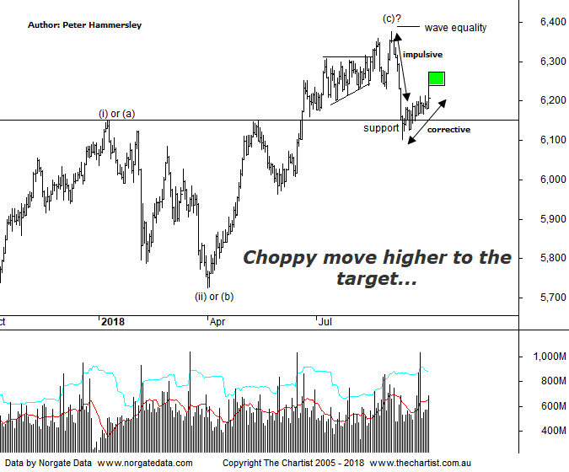

Bottom Line
28/9:
Daily Trend: Up
Weekly Trend: Down
Monthly Trend: Up
Support Levels: 6102 / 5786 / 5629 - 5611
Resistance Level: 6373 / 6490 / 6851
Video Analysis
Watch Video Analysis Here
Technical Discussion
US markets have continued to March onwards and upwards over the past few weeks, with the Dow Jones gaining over 11% from the low made on the 20th of June this year. The reason for mentioning this fact is that during the same period our market has gained less than 1%. Nothing new there you might say, as this has been the trait for most of the rally off the 2009 lows. The question is, can US markets continue to March higher? Perhaps not - according to Capital index. They suggest that although the Fed raised its GDP projection for 2018, headwinds are starting to appear. The Markit PMI saw a strong decline in the composite index which fell to its lowest level since June 2017 recently which is significant because it tends to correlate with US GDP. The theory is that a decline in the PMI suggests US growth could slow. Should this transpire then the US stock markets could suffer. The reason being, US GDP and equity markets generally move in the same direction. In other words, GDP has been moving higher in unison with the S&P 500. The opposite is true, meaning a fall in GDP could cause weakness in US equity markets. This is assuming the correlation continues. PMI data and US payrolls is due next week so let’s see if they prove to be significant. There is also private sector jobs and trade and construction spending due. On the earnings front here in Australia it’s the turn of Bank of Queensland, whilst ASX & MFG hold AGMs. China is closed all next week for the National Day holiday.
Reasons to be slightly cautious:
→ Fears regarding a potential trade war have heightened.
→ Tightening US monetary conditions.
→ Cracks are starting to appear in markets that are rarely discussed in the general media, i.e. credit markets
→ Inflation looks to remain stagnant till at least 2020
→ The Australian dollar is at risk of declining significantly
→ Choppy price action higher.
Last week we concentrated on the weekly chart which showed a couple of Cup & Handle patterns on different timeframes which in isolation is bullish, especially as the trigger points have been overcome on both. The problem for us the is that until our line in the sand at 6490 is overcome its more likely that a corrective pattern higher has been unfolding as opposed to something more bullish - which is the case with US markets. That make or break point came close to being tagged a few weeks ago although it remains a stumbling block. We’ll go back to the daily chart tonight which shows that although strength has been unfolding over the past three weeks or so it’s hardly been convincing. One fact we can’t get away from is that from the high of wave-(c) an impulsive leg lower kicked in, albeit buyers stepped up around the line of support. This is always an early warning sign, especially when the patterns are in a position where an impulse cannot complete the whole corrective pattern - which is true in this case. The bottom line is, our market is struggling for traction although it isn’t particularly weak. Big miners like BHP and Rio have started to head higher which is a positive although due to the weighting of the banks (almost 30%) it’s going to be exceptionally difficult for the XJO to trend higher without their help. The banks have fundamental headwinds and investors don’t appear inclined to overlook these at this juncture.
Trading Strategy
No formal recommendations have been put forward this week. This is reflective of the performance of the broader market which continues to be range-bound. Not that we have deliberately refrained from putting opportunities forward as this isn’t the case. When the setups present themselves, they will be placed in the position status page. Just remember, setups are available in the reviews themselves during the week even if there is no formal recommendation.

