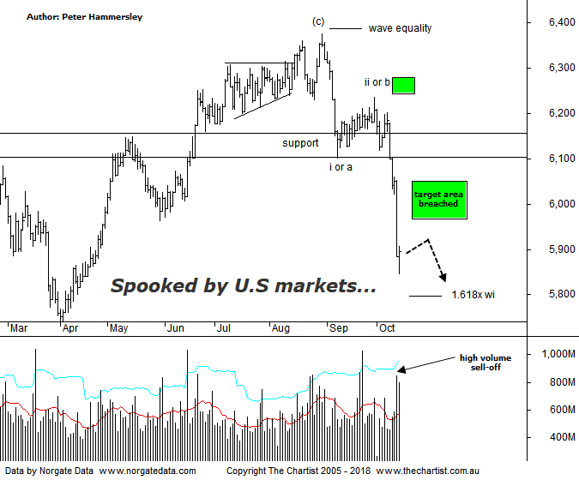

Bottom Line
5/10:
Daily Trend: Down
Weekly Trend: Down
Monthly Trend: Down
Support Levels: 5752 / 5629 - 5611
Resistance Level: 6102 - 6161 / 6373 / 6490 / 6851
Video Analysis
Watch Video Analysis Here
Technical Discussion
“…Many analysts are suggesting that if the 10-year heads up through 3.25% then equity markets could turnaround sharply and embark on a significant correction. Last night the yield rose up to 3.23 percent which concerned some on Wall Street…” Some would call this week’s weakness in US equities a random event although it now seems clear that bond rates have been the culprit. Long-dated Treasuries continued to sell-off this week, with strong economic data and expectations regarding future interest rate hikes behind an uptick in yields. Overnight, yields pulled back slightly although it didn’t stop the sell-off on Wall Street. To cut a long story short, recent economic data has now got the attention of investors, as the inflationary outlook could be changing. One thing the market doesn’t want is inflationary pressure which now appears to be more likely than it was a few months ago. After the rout in US indices on Wednesday it was only to be expected that our market would suffer as a consequence - and so it did. Most sectors took a big hit yesterday although not surprisingly gold was the only winner. Although last night’s session in the US wasn’t quite as dire the Dow Jones still managed to lose over 2% which was near the session’s lows. Considering this weakness, the XJO today performed relatively well with initial weakness being met with buyer demand. A small positive although one thing is for sure, if US indices continue to head south it’s going to be difficult, if not impossible to buck the trend. Uncertainty has returned and as such caution is required. In the US, quarterly results season swings into action. Earnings this time around will be watched closer than ever. Industrial production, housing sentiment and starts, plus retail sales data will be announced with minutes of the September Fed meeting also released. Chinese retail sales, industrial production, quarterly GDP and inflation data is also due next week.
Reasons to be slightly cautious:
→ Rising bond yields a possible issue.
→ Fears regarding a potential trade war have heightened.
→ Tightening US monetary conditions.
→ Cracks are starting to appear in markets that are rarely discussed in the general media, i.e. credit markets
→ Concerns over inflation increasing.
→ The Australian dollar is at risk of declining significantly
→ Choppy price action higher.
→ Impulsive price action lower has kicked in.
What a difference a week makes. During our review last Friday we suggested that a push down through the zone of support would result in a continuation lower into the target area either side of 6000. Not only has this transpired but our target has been smashed which opens the door for a deeper retracement to unfold. The big question is how deep the current retracement is going to travel though obviously much depends on whether US markets have just seen another blip or the start of something more significant. What I can say is that the line in the sand we’ve been watching for an eternity just beneath 6500 hasn’t been penetrated meaning we are still of the opinion that a corrective pattern higher has been unfolding. That line in the sand would still need to be breached before putting a more bullish wave count on the weekly chart (not shown). In the meantime, we’ll continue to follow the smaller degree patterns on this daily chart. I have put forward the 1.618 projection of wave-i which sits at 5796 which is now within touching distance. If buyers step up at those lower levels a bounce could materialise although that’s all we’d be looking for - a rally only as opposed to something more bullish. Should a 5-wave move lower unfold then a larger corrective pattern is likely still in its early stages. We’ll look at the larger degree patterns over next couple of weeks although suffice to say, if the sell-off continues there is scope to head all the way down toward 4700 although this would obviously be a much longer-term target area. It would also be the worst-case scenario.
Trading Strategy
After yesterday’s rout we took further defensive action last night by tightening protective stops. This has resulted in us now holding just one long position - MIN. We’ve also cancelled a couple of pending trades due to the patterns invalidating. I’m quite happy to sit out of the market until this bout of volatility subsides. If we are correct and lower prices are to be the way forward we’ll be looking to place some short set-ups in the position status page, but only when the patterns permit. Remember, being out of the market is a valid strategy in itself. If you trade the systematic systems abide by all recommendations irrespective of broader market conditions.

