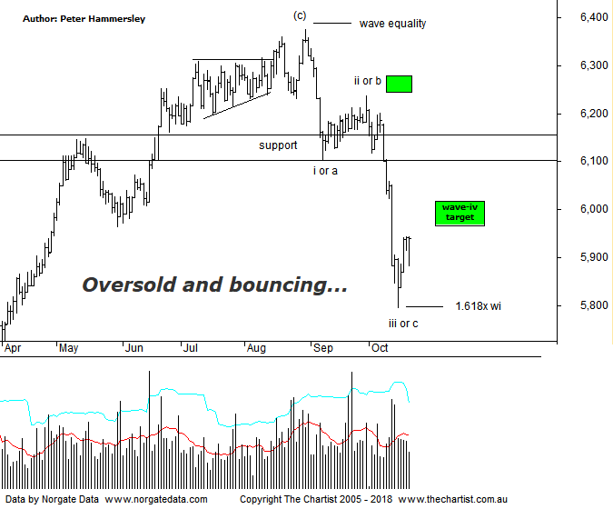

Bottom Line
19/10:
Daily Trend: Down
Weekly Trend: Down
Monthly Trend: Down
Support Levels: 5752 / 5629 - 5611
Resistance Level: 6102 - 6161 / 6373 / 6490 / 6851
Video Analysis
Watch Video Analysis Here
Technical Discussion
Not surprisingly the press has turned their attention to the anniversary of the 1987 stock market crash which wiped out over 22% on the Dow Jones in one hit. The anniversary is tomorrow in the US which has a few analysts and investors biting their nails. Of course, the chances of exactly the same happening on the same day is incalculable although there is no doubt that equity markets have increased in volatility, so it isn’t impossible. Personally, I remember the 87 crash very clearly as it was only a few months prior that I became interested in equities. Putting hard earned cash into the stock market only to see it halve in value within a few weeks is not a good feeling! However, it was the best lesson I ever learnt as it highlights the need for risk management, although we won’t go into details here. Irrespective of the outcome in the US this evening, a few headwinds have started to show. The decline in the Dow Jones that commenced on the 3rd of October is just under 8% which pales into insignificance compared to the prior multi-year trend. However, the fact that impulsive price action lower has started to show is a warning sign. This first transpired back in late January this year, with a straight-line movement down unfolding. Off the subsequent low, price action has for the most part been choppy and messy in nature which is another warning sign. Latterly of course, a straight-line leg lower has once again kicked in. Not that I’m suggesting this is the precursor to some type of a crash although a deeper retracement wouldn’t come as a great surprise. Next week sees US earnings season kick into full swing which can always provide volatility. So far, results haven’t been disappointing although undoubtedly a few investors remain nervous. The highlight in the US at the end of next week is the first estimate of September quarter GDP. This will be keenly watched by analysts; data recently has been strong which puts the spotlight back on higher US rates. House prices, consumer sentiment, new and pending home sales and durable goods data is also released next week. Here in Australia, it’s a quiet week although quarterly production reports will continue to be released from companies sitting within the resource sector.
Reasons to be slightly cautious:
→ Rising bond yields a possible issue.
→ Fears regarding a potential trade war have heightened.
→ Tightening US monetary conditions.
→ Cracks are starting to appear in markets that are rarely discussed in the general media, i.e. credit markets
→ Concerns over inflation increasing.
→ The Australian dollar is at risk of declining significantly
→ Choppy price action higher.
→ Impulsive price action lower has kicked in.
With the wave equality projection breached during our last review on Friday, there was good chance that price needed to head down to the 1.618 projection of wave-i which is now a box that can be ticked. In fact, that level sat at 5795, with the recent pivot low coming in at 5796, just one point higher. Coincidence? There are many analysts who are sceptical regarding Fibonacci ratios and the Wave Theory although we disagree. Fibonacci targets prove to be significant time and time again which is why we believe they provide an edge regarding projecting potential reversal zones and target areas. I have annotated Mondays low as completing wave-iii or-c although the prior is likely correct. The reason being, the leg down that commenced in late September has been strong and impulsive in nature and has extended which is more indicative of a third leg. Normally wave-iv will head up to the 38.2% - 50% retracement zone of wave-iii which provides the target area as annotated just above current levels. The further price heads up through the upper boundary just above 6000, the greater the chance that an interim low is already locked in although at this stage this cannot be our highest expectation due to the potency of the decline over the past few weeks. From a time perspective the current bounce needs to take longer to conclude as generally wave-iv tends to be a flat correction or a triangle. In other words, the bounce over the past few sessions should only be the initial stages of a corrective pattern higher. The bottom line is, despite the current show of resilience there’s no reason to be overly optimistic.
Trading Strategy
Today we were stopped out of our remaining long position meaning for now we are out of the market. This isn’t a deliberate act but a result of being proactive with protective stops which is something we must always be, irrespective of whether we are locking in profits or losses. If we are correct, with our market currently being in bounce mode only it could be that a few short set-ups will be presented although for now we are happy to remain sidelined. Just remember, being out of the market is a strategy in itself. There are no rules stating we must be involved all of the time.

