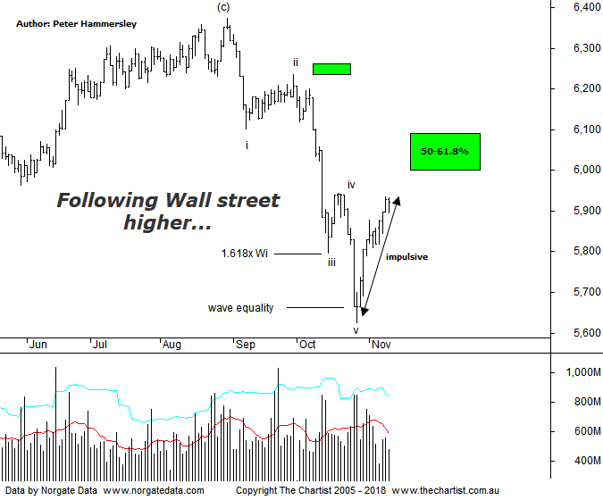

Bottom Line
9/11:
Daily Trend: Up
Weekly Trend: Down
Monthly Trend: Down
Support Levels: 5629 - 5611
Resistance Level: 6102 - 6161 / 6373 / 6490 / 6851
Video Analysis
Watch Video Analysis Here
Technical Discussion
It would be fair to say that US markets took the mid-term results in a bullish light, with most indices heading higher by around 2%. This did nothing to kick our local market into gear yesterday despite it closing in the green. However, the XJO was stronger during the prior session which probably accounts for this underperformance. Not surprisingly US indices took a pause for breath last night, so it will be interesting to see whether strength resumes overnight and into next week. If it does then there’s a good chance that our local market is going to follow suit, at least to some extent. The next major highlight is probably going to be Trumps meeting with China at the G20 which could hold a few surprises. Let’s also not forget that this is normally a good month for stocks, plus there’s the Santa rally to consider a little further down the track. Many analysts in the US are calling the recent retracement as being done and dusted although this is far from set in stone. On the face of it a lot of good news seems to be circulating although as usual this is likely already factored into price. In fact, it can be a contrarian signal. The mid-terms meant that the Fed meeting for once didn’t make headline news although nothing unexpected materialised. Also of course results season is coming to an end in the US which for the most part has been positive. Next week sees retail sales, CPI, and production numbers, with a similar situation occurring in China next week. Oil has been in the news for all the wrong reasons as it’s been retracing with some intent recently. OPEC and non-OPEC countries meet over the weekend to discuss production quotas which again could trigger some volatility. Here in Australia the Westpac consumer confidence and National Australia Bank business surveys will be released. October jobs data and the September quarterly wage price index are also due.
Reasons to be cautious:
→ Housing weakness could be a problem for the big banks.
→ Improved earnings due to cost-cutting could have done its dash.
→ Weakening sentiment and increased competition in electrical goods.
→ Australian trading should continue to weaken as the housing market kills.
→ A marked slowdown in sales momentum and poor underlying cash flow.
→ Competitive pressure remains an issue.
→ A recent survey shows Amazon is around 15% cheaper than Australian retailers.
→ More evidence suggesting a cyclical high is close.
→ Cost cutting may have run its course, which has been the driving force for earnings.
From a pure pattern perspective, the ideal situation was to see short-term weakness this week as this would have provided confidence that a bounce only was underway. However, the rally has continued which is putting pressure on the smaller degree patterns. We’ve undoubtedly seen 5-waves down from the high made on the 30th of August which in normal circumstances would set the stage for a 3-wave move higher into the 50% - 61.8% retracement zone as annotated just above 6000. It now seems likely that target is going to be achieved although at this stage it isn’t looking like a corrective pattern. This could be a bullish proposition over the coming weeks although it’s less than ideal from an Elliott perspective as clarity is starting to fade. Price would need to head down pretty much immediately toward 5800 as a minimum to get the patterns back on track. Much is going to depend on the performance of the US which as mentioned above surged once the mid-terms were done and dusted. The line in the sand sits at 6087 which is the 61.8% retracement level of the prior leg down. The further price gets up through that make or break point the more confident we can be that the pivot low made just over a couple of weeks ago is going to hold firm, and not be penetrated. All we can do for now is concentrate on the target area just above current levels as this is going to be key in relation to the larger degree patterns. Interestingly, our divergence oscillator has only just started to head higher out of the oversold position on the weekly chart (not shown) although it’s less significant as bullish divergence isn’t in place.
Trading Strategy
We continue to stand aside this week with no formal recommendations issued although setups have been put forward in the reviews themselves if you want exposure to the market. Just remember, standing aside until the dust settles is a valid strategy in itself. There are no hard and fast rules stating we must hold positions all the time. Should a corrective pattern take price into the typical retracement zone we’ll continue to focus on putting forward short-setups although patience is going to be required.

