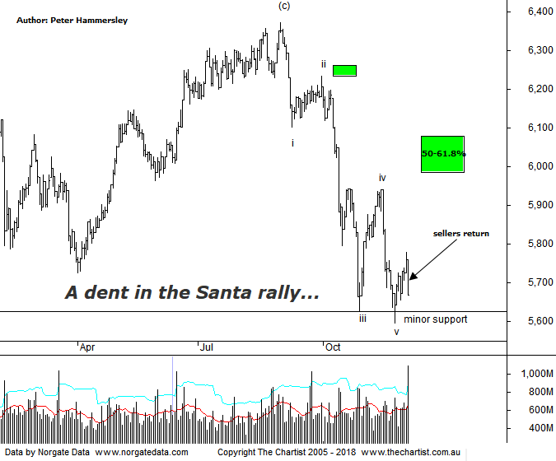

Bottom Line
30/11:
Daily Trend: Neutral
Weekly Trend: Down
Monthly Trend: Down
Support Levels: 5594 / 5052 - 4976
Resistance Level: 6102 - 6161 / 6373 / 6490 / 6851
Video Analysis
Watch Video Analysis Here
Technical Discussion
We couldn’t have asked for anything more from Wall Street over the past couple of sessions, with Wednesday being especially strong as indices rallied around 2%. Overnight, the Dow initially headed lower by around 150 points although following the strong prior session this doesn’t come as such a big surprise. However, buyers stepped in resulting in a close just beneath breakeven which was viewed as being positive from analysts. The reason for the rally was likely the Fed minutes which strongly suggested that a rate rise in December is likely. However, the central bank apparently doesn’t have an agenda thereafter. The bottom line is, the Fed want to await further data before making any firm decisions. In other news, Trump’s lawyer has now admitted that he lied about plans for Russia in the lead up to the election. Headline news, although it’s unlikely to have any effect on markets, especially as this goes back to 2017. What could move markets is the outcome of the meeting between Trump and Xi which is still an unknown. On the data front, Monday sees manufacturing PMI’s from several countries which will be interesting as global economic growth (or not) is front and centre at the moment. In the US, factory orders, consumer sentiment and private sector jobs will be followed by non-farm payrolls due on Friday. Here in Australia the RBA meet on Tuesday although there are also quarterly numbers for company profits and inventories, the current account and terms of trade plus the September GDP result to look forward to. The big story though is going to be what comes out of Buenos Aires.
Reasons to be cautious (upside short term):
→ Housing weakness could be a problem for the big banks.
→ Improved earnings due to cost-cutting could have done its dash.
→ Weakening sentiment and increased competition in electrical goods.
→ Australian trading should continue to weaken as the housing market kills.
→ A marked slowdown in sales momentum and poor underlying cash flow.
→ Competitive pressure remains an issue.
→ A recent survey shows Amazon is around 15% cheaper than Australian retailers.
→ More evidence suggesting a cyclical high is close.
→ Cost cutting may have run its course, which has been the driving force for earnings.
Following a couple good sessions in US markets it may seem strange that the XJO sold-off today. In fact, although yesterday saw a close in the green it was hardly inspiring considering US indices headed higher by around 2% the night prior. The reason is probably the G20 summit which has plenty of traders and investors biting their nails. Our market will be one of the first to trade following the summit meaning we won’t have a lead from US markets. As we know only too well now, over the past few years we haven’t liked standing on our own two feet. As far as the patterns are concerned nothing changes and unless something comes out of left field over the weekend, we still expect price to head up into the target area circa 6000. It goes without saying that we need to be a little cautious with potentially market moving news unravelling over the next couple of days. One thing is for sure, we don’t want to see another day like today otherwise price is going to retest the line of support again which would be one retest too many. A push down through the low of wave-v would invalidate our wave count meaning we’d have to move back to the weekly timeframe to try and find some clarity. However, should this more bearish scenario unfold then the recent pivot high which terminated just beneath the typical retracement zone is likely the full extent of the bounce. Not ideal from an Elliott perspective although unless the much-vaunted Santa rally kicks into gear with a vengeance it’s more than feasible. Either way, whether price can head higher into the 50% - 61.8% retracement zone or not, it’s difficult to get overly confident medium to longer-term which again comes down to the potency of the leg lower off the high made at the end of August. For now, let’s see what comes out of the summit although no headline news will probably be good news.
Trading Strategy
We have put forward several pending trades this week although currently only hold one long position, which is Spark. However, we will continue to put forward both long and short setups as they present themselves, irrespective of potential market moving events. That said, there’s still every reason to be cautious. Don’t forget, being out of the market completely until the dust settles, or even just reducing risk are strategies within themselves. If you are aligned to the systematic portfolios continue to adhere to all signals irrespective of outside influences.

