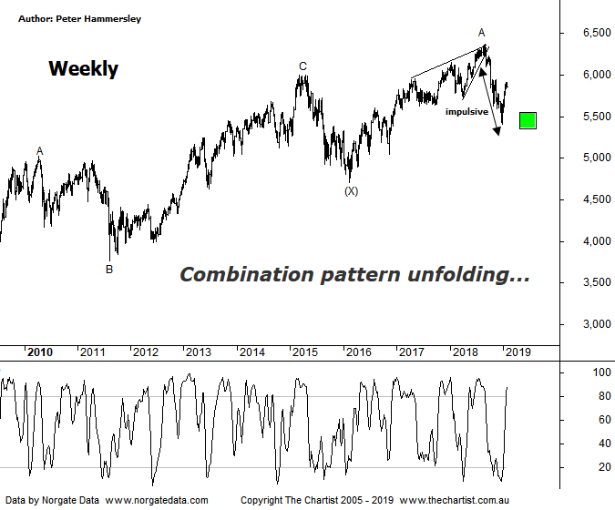

Bottom Line
1/2:
Daily Trend: Down
Weekly Trend: Up
Monthly Trend: Down
Support Levels: 5052 - 4976
Resistance Level: 5891 - 6005 / 6373
Video Analysis
Watch Video Analysis Here
Technical Discussion
Following the wobbles on Wall Street (which commenced in October last year) the likes of the Dow Jones are now in recovery mode, with decent trends unfolding following Christmas. Not only have US indices bounced but price action has been strong and impulsive in nature. In other words, buyers keep stepping up to the plate during weakness which of course has been the trait in the US for many years. Over more recent times we have been following Wall Street higher although the past few sessions has seen a change of heart. Both yesterday and today initial strength was sold into although there’s probably a good reason for it. The Royal commission report on the banks is due out today although it won’t be released until after our local market closes on Monday. The reason apparently is to avoid volatility. We must also bear in mind that the banks have enjoyed a decent run recently, so a few traders and investors have been taking profits ahead of the report being released. For now, it’s the resource sector which is gaining some traction, with the likes of BHP (refer yesterday’s review) looking strong. The rising price of oil has also been helping sentiment. The other possible headwind for our local market is China which continues to produce data suggesting it’s slowing. It’s also worth remembering that China is closed all next week. In the US, jobs data is released this evening with next week seeing services PMI and factory orders. The big news here though is going to be the Royal commission report due aftermarket on Monday. It could be a damp squid - it could also cause some nasty price action.
Reasons to be cautious (upside possible short term):
→ Commodity prices and the housing market remain under pressure
→ Domestic economy remains in a slumber. GDP prints well below expectations
→ RBA battling low inflation, weak wages and record low savings
→ Deputy Governor calls on big banks to ease up on lending restrictions
→ Trump administration remains in disarray - Defense Secretary 'retires' unexpectedly
→ Global markets nearing bear status with record outflows from US mutual funds
Over the past couple of weeks we’ve noted that the smaller degree patterns have deviated from the expected path although this has opened the door for something more bullish to unfold. With price consolidating this week it provides us with the opportunity to take a step back and concentrate on the weekly chart to try and find some clarity. Let’s start from the beginning. In 2009 the rally commenced which still appears to be corrective in nature, albeit at much larger degree. What we are left with is an A-B-C correction up to the highs made in early 2015. The subsequent retracement was short in both terms of price and time suggesting a combination pattern is unfolding which is why we’ve labelled it as a wave-X. As we’ve said many times before the problem with complex combination patterns is that they can become even more intricate although in this instance one of two things should be unfolding. The first move higher unfolded as a zigzag, meaning the second could either be another zigzag or a flat pattern although we’ll look at both scenarios in more detail during this evening’s video for clarity. The one thing we can’t get away from is the fact that the leg lower from wave-A which commenced in August of last year has been strong and impulsive in nature which should not complete the whole corrective pattern, irrespective of it hitting the typical retracement zone. In other words, even if the current bounce continues, we wouldn’t expect it to head up through the high of wave-A before seeing another significant leg South. That said, this still offers plenty of upside potential over the short to medium term.
Trading Strategy
“…Our strategy has always been to trade the patterns within the individual stocks themselves as opposed to being led by our expectations of the broader market. We don’t use a market filter although there are plenty of traders and investors that do…” Setups have been presented recently and we now find ourselves with 7 open long positions. We have a couple of defensive stocks in the mix which clearly aren’t in demand due to the recent market rally so we may be adjusting protective stops over the course of next week so keep a close eye on the position status page for amendments. We’ll also be putting more opportunities forward over next few weeks, patterns permitting.

