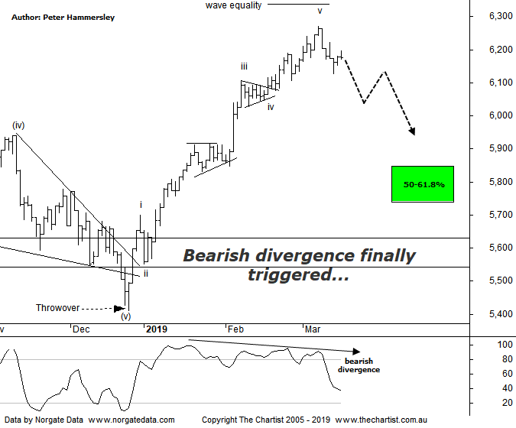

Bottom Line
15/3:
Daily Trend: Down
Weekly Trend: Up
Monthly Trend: Up
Support Levels: 5996 - 5950 / 5410 / 5052 - 4976
Resistance Level: 6373
Video Analysis
Watch Video Analysis Here
Technical Discussion
After following US indices higher over the past few weeks the XJO has point-blank refused to head higher this week although plenty of stocks went ex-dividend which has skewed the numbers somewhat. That said, we’ve noted over the past two or three weeks that our market is looking overbought over the short-term and there is still a feeling that investors believe our market is fully valued at this point in time. One thing we must be cognizant of is the weighting of the banks, which is around 30%. In other words, if the XJO is to head higher without them, the likes of BHP and RIO are going to have to fill that void. One thing is for sure, the Materials Sector has been doing a fine job over the past few months although of course nothing goes up in a straight line indefinitely. The sector is currently taking a pause and could even had to lower levels before a low is locked in. Following the initial surge from the banks on the back of the Royal commission, momentum has been fading recently which has obviously affected the broader market performance. Longer-term there is still plenty of upside for the likes of CBA, but large consolidation patterns appear to need more time before concluding. The bottom line is, if the big blue chips are in a period of consolidation it’s going to be difficult for the ASX-200 to gain much traction. As always, news events are going to be a key factor, especially with the ongoing US-China trade talks competing with Brexit to make the front page. Here in Australia, December quarter house prices and population data is released, along with February jobs and the minutes of the March RBA meeting. There are still plenty of stocks going ex-dividend next week although the list is shortening.
Reasons to be cautious (upside possible medium term):
→ Brexit situation deteriorating
→ Commodity prices bouncing but the housing market remain under pressure
→ Domestic economy remains in a slumber. GDP prints well below expectations
→ RBA battling low inflation, weak wages and record low savings
→ Deputy Governor calls on big banks to ease up on lending restrictions
→ Trump administration remains in disarray - Defense Secretary 'retires' unexpectedly
→ Global markets nearing bear status with record outflows from US mutual funds
From an Elliott stance we were in a position to see the completion of wave-v following our last review although there was scope to head up to the wave equality projection as annotated. This is still feasible although finally the Type-A bearish divergence we’ve been watching for two or three weeks now has triggered. In fact, our indicator is now within touching distance of the oversold position meaning it shouldn’t be a headwind for too much longer. However, even if the divergence unwinds it doesn’t automatically follow that strength is going to kick back into gear with a vengeance. If we have seen a completed 5-wave move higher the door is open to see a 3-wave corrective pattern lower toward the typical retracement zone as annotated sitting between 5840 - 5739. Of course, this assumes that an interim top is in place although it’s still early days regarding the current retracement. For the symmetry of the patterns it’s important that any weakness is choppy and messy in nature as opposed to being impulsive as this will provide confidence in expecting another leg higher further down the track. Should this be the way forward then the all-time highs set in 2007 at 6851 could be achieved and even exceeded by a small margin although this is looking much further down the track. Our stance off 2009 lows has always been that a corrective pattern higher was going to unfold and despite recent strength, nothing changes. Price can head into blue sky territory and still be within a larger corrective pattern. In the meantime, let’s see if the current retracement continues next week as this would be ideal from a pure pattern perspective.
Trading Strategy
Patterns in many stocks we cover are starting to reset which ideally will provide plenty of opportunities over the coming days and weeks. We now have three trades waiting in the wings to trigger and won’t hesitate to put more forward as they present themselves. However, if we are correct with our wave count here which advocates lower prices over the short-term, a little caution is required as we don’t want to jump the gun and get overly exposed during a period of potential weakness.

