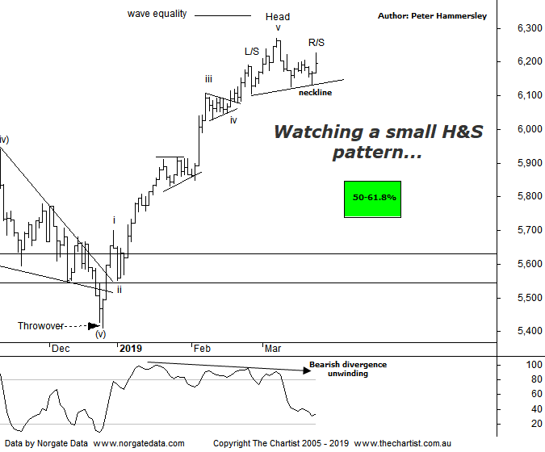

Bottom Line
22/3:
Daily Trend: Neutral
Weekly Trend: Up
Monthly Trend: Up
Support Levels: 5996 - 5950 / 5410 / 5052 - 4976
Resistance Level: 6373
Video Analysis
Watch Video Analysis Here
Technical Discussion
Without much in the way of a lead from US markets, the XJO has been lacklustre this week which shouldn’t come as a big surprise considering we’ve had technical headwinds in place. We’ll cover these in more detail below although suffice to say there is still room for lower prices over the coming weeks. Today was much better although the close was off the highs of the session. It would be healthy to see a more significant retracement although for now stocks have stalled only as opposed to selling-off with intent. As always, there are news events that could have a significant effect, which essentially comes down to Brexit and the US-China trade talks. The latter don’t appear to be in a rush to come to an agreement although for now markets are taking it in their stride. If these talks continue to drag on though it could be a different story. Brexit of course is a known unknown, with the can continuing to be kicked down the road. Data in the US continues to be postponed and rescheduled as they continue to play catch up. However, data for consumer confidence, housing starts, pending and new home sales and house prices should be released next week. Here in Australia, there’s only private sector credit numbers due.
Reasons to be cautious (upside possible medium term):
→ Brexit situation deteriorating
→ Commodity prices bouncing but the housing market remain under pressure
→ Domestic economy remains in a slumber. GDP prints well below expectations
→ RBA battling low inflation, weak wages and record low savings
→ Deputy Governor calls on big banks to ease up on lending restrictions
→ Trump administration remains in disarray - Defense Secretary 'retires' unexpectedly
→ Global markets nearing bear status with record outflows from US mutual funds
The ideal situation is still to see lower prices which may seem a strange thing to say considering we hold plenty of long positions. However, we must see symmetry in terms of the patterns as well as time. It’s been a stellar leg higher from the December lows with any short retracements or consolidation patterns bringing out the buyers. This is extremely positive although of course nothing goes up in a straight line indefinitely. We’ll stick with our wave count which shows wave-v is locked in although as mentioned previously, there could be one final probe up toward the wave equality projection before a more significant countertrend movement lower unfolds. I believe this is unlikely though, which comes down to how the smaller degree patterns have subdivided. For now, there is plenty of symmetry which keeps the door open for further weakness. Also, many companies continue to exhibit bearish divergence which usually limits upside as a minimum although it can just as easily produce a retracement. Bearish divergence on this chart is still in place although our indicator is now within touching distance of the oversold position meaning it’s not going to be a headwind for too much longer. Although it took its time, it has had an influence on price and will likely continue to do so over the coming days. If price heads down immediately a small Head & Shoulders pattern could be locked in although the neckline would need to be overcome before it triggers. This would portend a push down to just beneath 6000 though the lower target area is more likely to be achieved if price gets down toward those levels.
Trading Strategy
Over the past couple of days, we have been triggered into a long position in ILU which brings our number of positions to 6. The obvious laggard is Westpac (WBC) which point blank refuses to head higher. We’ll give it a while longer to prove itself before selling as we don’t want to be holding stocks that are stagnant. Plus, the Banking sector has stalled following the initial spike triggered by the Royal commission findings. We currently have 3 positions waiting to trigger in the position status page if you are looking for opportunities.

