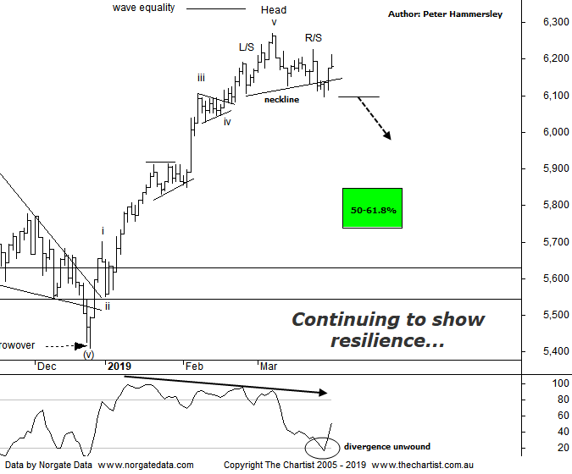

Bottom Line
29/3:
Daily Trend: Up
Weekly Trend: Up
Monthly Trend: Up
Support Levels: 5996 - 5950 / 5410 / 5052 - 4976
Resistance Level: 6373
Video Analysis
Watch Video Analysis Here
Technical Discussion
Global equity markets have been struggling for direction recently, with the Dow Jones continuing to track sideways which appears to be forming a small symmetrical triangle. As long as the breakout is to the upside US indices should be back in Bull mode over the coming weeks. It’s been a long time since we’ve had little news to move markets although this appears to be the case. The China - US trade talks are progressing well if we believe what we are being told although the bottom line is, no agreement has been reached. The other topic on investors lips has been global growth concerns which haven’t been helped by plunging US bond rates. These stabilised overnight which has calmed some nerves although whether this trait continues is anyone’s guess. After a directionless week, yesterday saw buyers return to our market which embarked on a strong afternoon rally. This sudden strength didn’t appear to coincide with significant news although clearly demand returned for a few hours. The big move overnight was Gold which declined by around $20.00, taking it back beneath the psychological $1300 an ounce level. Not surprisingly, this triggered weakness in the sector today. On the data front, China releases manufacturing and services PMIs over the weekend, with others to follow on Monday. There is always weekly data released in the US although nothing appears to be market moving over the coming days. Here at home retail sales, trade and building approvals numbers will be released. Let’s also not forget tonight sees a vote in the Brexit drama.
Reasons to be cautious:
→ Brexit situation deteriorating
→ Commodity prices bouncing but the housing market remain under pressure
→ Domestic economy remains in a slumber. GDP prints well below expectations
→ RBA battling low inflation, weak wages and record low savings
→ Deputy Governor calls on big banks to ease up on lending restrictions
→ Trump administration remains in disarray - Defense Secretary 'retires' unexpectedly
→ Global markets nearing bear status with record outflows from US mutual funds
Last week we put forward a small Head & Shoulders reversal pattern with the R/S likely locked in. This is still the case, with the neckline of the pattern being overcome almost immediately. Normally this triggers a continuation South although this hasn’t been the way forward - at least not yet. The bottom line is, our market is remaining resilient, albeit it has been taking a breather over the past few weeks. As long as US markets can hold themselves together Price could continue to meander sideways as opposed to heading lower with any degree of attitude. From a pure pattern perspective, I would still like to see the typical retracement zone either side of 5800 tagged although of course we don’t always get the perfect symmetrical patterns - or what we want. One thing is for sure, a push up through the Head at 6271 means the H&S becomes a continuation pattern which although bullish short-term would be less than ideal from a more conventional pattern perspective - as well as from an Elliott stance. The bearish divergence we’ve been watching is no longer a headwind, with our indicator having tagged the oversold position recently. That’s not to say it portends immediate strength but it’s one less tailwind in our quest for a reasonable retracement. A quick look at the weekly chart (not shown) adds weight to the case for a deeper retracement, which comes on the back of a more complex combination pattern likely unfolding although we’ll take a closer look at the larger degree patterns shortly.
Trading Strategy
We have been triggered into 3 more long positions this week taking our total up to 8. This may seem strange considering we are looking for a reasonable retracement in the XJO although let’s not forget, it’s the patterns pertaining to the individual stocks themselves which are more significant. Plus of course, we could be totally wrong in expecting broader market weakness, irrespective of whether it’s ideal from a pattern perspective or not. That said, we don’t want to be buying with our ears pinned back just for the sake of it. Remember, we put forward many recommendations in the written reviews even if they don’t make it into the position status page. One that comes to mind is Bellamy’s (BAL) which is a company we reviewed for the first time yesterday.

