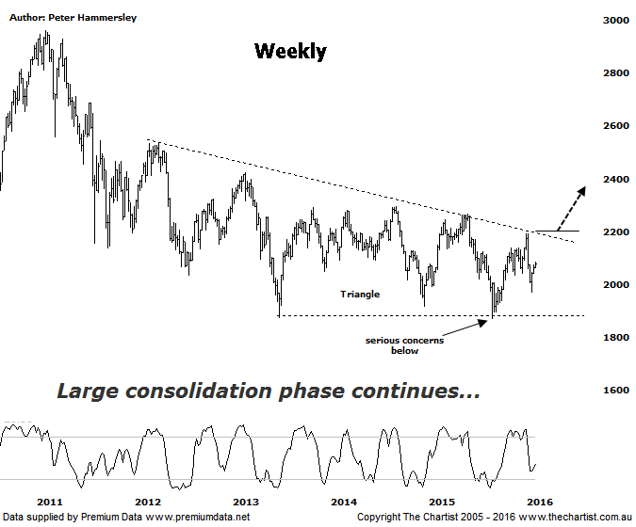

Bottom Line
1/2:
Daily Trend: Up
Weekly Trend: Down
MonthlyTrend: Down
Support levels: 1971 /1870
Resistance levels: 2266 - 2296
Video Analysis
Watch Video Analysis Here
Technical Discussion
Price action was looking pretty good during our last review back in late December due to a comprehensive break up through a zone of resistance. However, momentum wasn’t sustainable and once again we are left with a false breakout which has been a Thorne in our side over the past few years. Not only did price fail to get on with the job but the subsequent decline was almost parabolic in nature which is concerning in itself. In a perfect world we need to see choppy retracements rather than straight line movements like the one here. This development leaves the XSO in a precarious position, despite the fact a decent rally has been unfolding over the past 3 weeks or so. The one positive, and something we have been noting over the past few reviews has been the outperformance of the index when compared to the XJO – at least over more recent times. Bigger picture of course the reverse is true but at least it’s a step in the right direction in regard to the beaten down small cap stocks making some sort of a come-back, even if it’s only within a much larger and longer term bounce scenario.
Reasons to be slightly more optimistic (caution short term):
→ Showing resilience in difficult market conditions.
→ Price has rebounded out of the zone of support.
→ Further stimulus out of China should be bullish for Australian equities.
→ Whilst traders are still continuing to chase yield a healthier looking market would increase confidence levels. The beaten down small caps will offer an alternative.
First of all, it has to be said that the smaller degree patterns are extremely difficult to decipher which is simply due to the choppy and messy price action that’s been unfolding pretty much since late 2011. Trends have been hard to come by that’s for sure, although tonight we are going to take a big step back and look at the bigger picture patterns via the weekly timeframe. The standout pattern is a descending triangle but although this gives us something to focus on it doesn’t really fit from an Elliott Wave perspective as it is out of sync both in terms of price and time. That said, we don’t have to label every single chart when clarity is lacking, as it is here. The upper trend line of triangle is essentially dangle resistance which has now been tagged and rejected on five separate occasions since early 2012. As a general rule of thumb, the more times it’s tagged and rejected the more significant it becomes. Although it’s not out of the question to see a downside break we’d obviously prefer to see the upper trend line overcome with a degree of attitude. At smaller degree price will normally break in the direction of the prior trend which in this instance is firmly down. However, the much larger patterns that take years to develop often prove to be reversal setups which is exactly what we are looking for here. For the moment though price is sitting pretty much in the middle of the pattern meaning it could be some time before a decisive breakout is seen in either direction.
Trading Strategy
Although a decent bounce has been unfolding we are by no means out of the woods in regard to seeing further weakness a little bit further down the track. In other words, I wouldn’t be chasing smaller cap stocks higher right here and now on the back of short-term strength. As mentioned above, if you are looking at this index in isolation then the diagonal line of resistance needs to be overcome before thinking in terms of something more bullish unfolding. If the breakout does unfold several weeks down the track look toward the measured move out of the triangle up around 2600 to be tagged throughout the rest of the year. This is purely hypothetical at this juncture though as there is still plenty of work to be done before the upper trend line is overcome. There are still reasons to be cautious at this stage.

