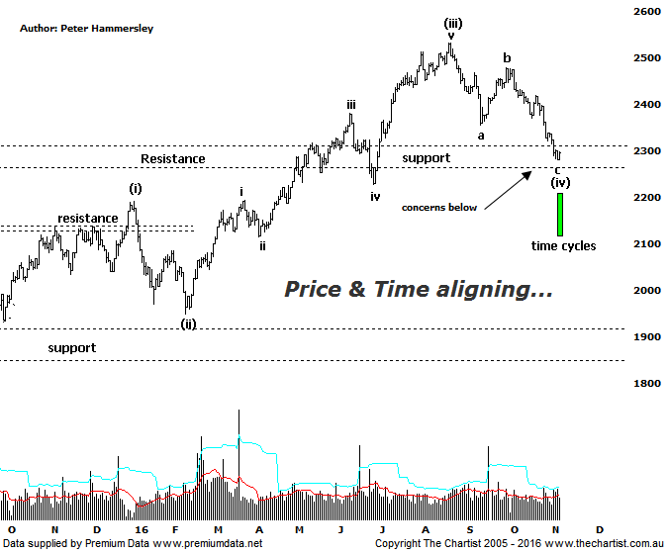

Bottom Line
7/11:
Daily Trend: Down
Weekly Trend: Down
MonthlyTrend: Down
Support levels: 2228 - 2191
Resistance levels: 2479 / 2532
Video Analysis
Watch Video Analysis Here
Technical Discussion
News over the weekend stating that there will be no charges against Hillary Clinton following the FBI review of emails has put the bid back into world equity markets. Until this news, futures were pointing to another negative open though the XAO jumped out of the blocks. Polls over the weekend also suggested that Clinton was ahead, albeit still only by a small margin. The market appears to believe that Trump’s chances have slightly diminished with US futures all pointing to an open of just over 1% higher. Whether this will be sustainable of course is the million-dollar question though we won’t know for another couple of days. As mentioned during our last review, which was less than two weeks ago, the Small Ordinaries has been under more pressure than the XAO recently. Indeed, the prior declined almost 8% down to Friday’s low with the XAO declining 5.7%. This just reiterates that investors are more risk averse. It also shouldn’t come as a great surprise considering that smaller cap stocks have been outperforming over the past few months by a substantial margin. It would be reasonable to assume that this trait will remain if the market likes the result of the US election. If it doesn’t, then it could be “look out below”, at least initially. There’s nothing wrong with continuing to be cautious until the dust settles later this week.
Reasons to be more optimistic (caution short term):
→ Outperforming the larger cap stocks over recent months.
→ Price is holding above a zone of support
→ Further stimulus out of China should be bullish for Australian equities.
→ Whilst traders are continuing to chase yield a healthier looking market would increase confidence levels.
→ The beaten down small caps will offer an alternative.
In Friday’s review of the XJO we noted the deterioration of the smaller degree patterns which also meant clarity was lacking. When this is the case we often move to different timeframes, usually by looking at the weekly chart although in this case we’re going to concentrate on the smaller cap stocks (XSO). This daily chart shows much clearer wave structures and is also showing more clarity using more conventional technical analysis. First of all, the descending triangle we were focusing on last time has been invalidated though this in itself isn’t major reason for concern. At this stage, another zigzag appears to be unfolding although if this is going to complete wave-(iv), which would be ideal then buyer’s need to appear pretty much immediately. A push beneath the lower boundary of the zone of support would be reason for concern and move us back to a neutral stance. There is a case for heading slightly lower, to wave-iv of one lower degree as this would normally be a common occurrence although it would less than ideal in this case as current support would then become new resistance on the way back up. The other interesting development has been bullish divergence with price making a lower low whilst our oscillator has failed to confirm by making a higher low. However, price would need to head higher immediately for the divergence to trigger, and therefore become significant over the short-term. The other interesting aspect of the chart is the annotated time cycle cluster which commenced on Friday and runs through to Wednesday. There are four time cycles making up the cluster which increases its significance. Obviously this coincides with the US election result, plus the fact that price has now hit a potential reversal zone in the form of the zone of support. In other words, there’s lots of confluence in this area both in terms of price and time. This doesn’t necessarily guarantee a strong reversal but it’s something to look out for later this week and into next.
Trading Strategy
The bottom line is that many of the smaller cap stocks have made significant headway over the past few months which is likely the reason for the deeper sell-off, especially compared to the blue chips. Also, as stated above, investors have become much more cautious due to the possible repercussions of the US election result, which again adds weight to the woes of the smaller cap stocks. Our stance remains the same, caution is required over next few days, irrespective of how we believe the election will turn out.

