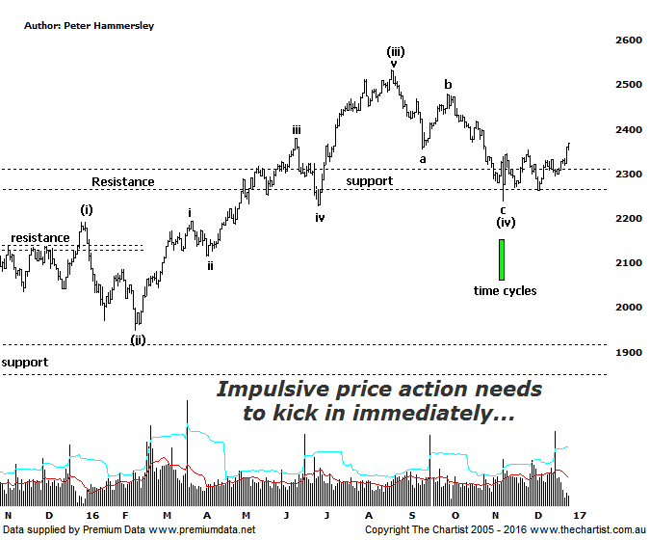
Bottom Line
29/12:
Daily Trend: Up
Weekly Trend: Up
MonthlyTrend: Up
Support levels: 2239 - 2228 / 2201 - 2123
Resistance levels: 2479 / 2532
Video Analysis
Watch Video Analysis Here
Technical Discussion
Although smaller cap stocks have outperformed the broader market over the medium term it certainly hasn’t been the case over more recent times. In fact, momentum has swung back toward the blue chips over the past few weeks with the big miners and banks pushing the XAO onwards and upwards. As an example, the Small Ordinaries (XSO) shown here has gained 5.4% since the 9th of November with the All Ordinaries gaining 11.6% which is a stark difference. That’s not to say we expect this trait to continue longer term, although for the moment the larger end of town remains the focus of investors and as such we must go with the flow. Ideally, next year will provide some bargains in the lower cap stocks although as usual, the proof will be in the pudding. We all know only too well that the reason for the recent surge in world equity markets has been Trumps victory which is being viewed as bullish for global growth. This has been the driving force for recent strength. Whether this continues longer term only time will tell although for the moment markets have given the big thumbs up to the US election result.
Reasons to be more optimistic:
→ Investors starting to take a “risk on” approach.
→ Outperforming the larger cap stocks over recent months.
→ Price is holding above a zone of support
→ Further stimulus out of China should be bullish for Australian equities.
→ Whilst traders are continuing to chase yield a healthier looking market would increase confidence levels.
→ The beaten down small caps will offer an alternative.
With trading volumes exceptionally low due to the holiday period, and nothing changing following our last review of the XJO we’ll take this opportunity to look at the patterns of the XSO. During our last review, we’d pencilled in an a-b-c correction which ideally completed wave-(iv). There were several reasons to be optimistic. First of all, the prior retracement looked symmetrical and appeared to have terminated on the zone of support. Secondly, buyers stepped up to the plate in numbers at those slightly lower levels causing a volume bubble which is always reason to sit up and take notice. Finally, there was a confluence of time cycles at the prior pivot low. However, despite higher levels being attained strength has been choppy and messy in nature which is reason for concern. If price is heading higher within wave-(v) strong impulsive price action should be the way forward and we’d be hard pushed to suggest this has unfolded. Indeed, price has been meandering sideways with a bias to the upside over the past few weeks which opens the door for something a little less bullish to unfold. The bottom line is that the XSO needs to trend higher in strong clean fashion immediately to move us back to a more bullish stance. This isn’t impossible, but there’s no doubting the fact that the smaller degree patterns have deteriorated since our last review. Having said that, our wave count remains in place for the moment, albeit by the skin of its teeth. One thing is for sure, a break beneath the recent pivot low at 2239 invalidates our wave count and will undoubtedly move us back to a neutral stance which is really something we don’t want to do. On the flipside, a rotation up through 2479 would be a big confidence booster making it a level to keep a close eye on should recent strength continue.
Trading Strategy
As mentioned above, it’s been the larger cap companies that have been pushing the broader market higher over the past few weeks although this doesn’t mean to say we must concentrate on the higher end of the market. We have exposure to the banking sector through both CBA & ANZ and currently hold BHP amongst others. Our strategy remains unchanged in that we let the patterns dictate which part of the market we enter. As we’ve stated before many times on these pages, the cream usually rises to the top which automatically results in getting involved in stocks with upside potential.

