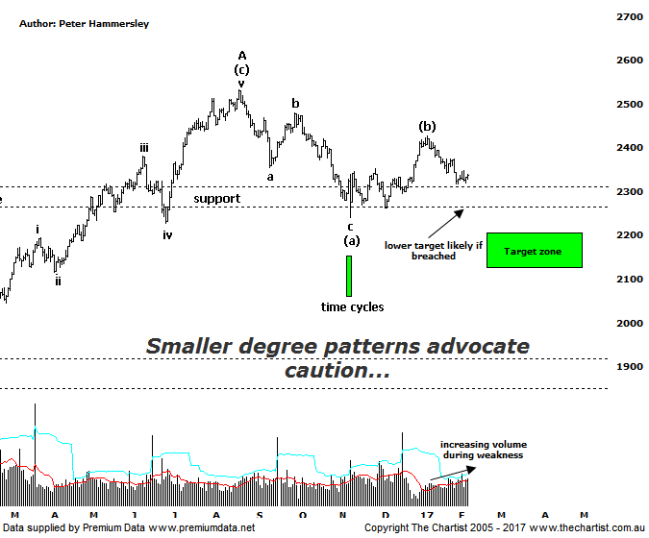

Bottom Line
8/2:
Daily Trend: Down
Weekly Trend: Neutral
MonthlyTrend: Down
Support levels: 2239 - 2228 / 2201 - 2123
Resistance levels: 2426 - 2479 / 2532
Video Analysis
Watch Video Analysis Here
Technical Discussion
In raging Bull markets (like the one taking place in the US) stocks tend to move higher in unison with the smaller cap stocks often outperforming which is mainly due to the risk being “on”. This simply hasn’t transpired here in Australia despite the XAO putting in a decent performance from the 2009 lows. In fact that index has rallied over 82%. Despite the smaller cap stocks (XSO) playing some catch up the index has only rallied 58% off the same lows. The reason being, it was the banking sector that led the charge from the lows around seven years ago. As we mentioned in last night’s review of the XXJ, most analysts and brokers are suggesting the banks are fully, or even overvalued although from a technical standpoint this isn’t the case. At the moment, it’s the turn of resources and the big miners like BHP, RIO & FMG to trend; the materials sector still looks strong, albeit some profit-taking is currently taking place. Those aforementioned companies still offer solid growth potential, and according to analysts look undervalued with the expectation of further upgrades to come. As far as the smaller cap stocks go, we still believe there are bargains to be had, especially in the resource sector.
Reasons to be more optimistic longer term (caution short term):
→ Investors have been taking a “risk on” approach.
→ Outperforming the larger cap stocks over recent months.
→ Price is holding above a zone of support
→ Further stimulus out of China should be bullish for Australian equities.
→ Whilst traders are continuing to chase yield a healthier looking market would increase confidence levels.
→ The beaten down small caps will offer an alternative.
Our headline last time was “… Impulsive price action needs to kick in immediately…”. The reason being, the rally from the zone of support was starting to look choppy and messy in nature which was the exact opposite of what was required. Unfortunately, the trait of overlapping wave structures has continued with price once more coming back toward the upper boundary of the zone of support around 2300. As such, we have put forward the alternate count which although not bearish longer term offers downside potential over the coming months. This amended wave count shows a 3-wave movement up to the pivot high made in August of last year. It now appears that waves-(a) and-(b) are in place with what should be the final probe down within wave-(c) already underway. The fact that impulsive price action down has been taking hold over the past few weeks only strengthens this more bearish analysis. Should the downturn continue we’ll be looking for price to head into the typical retracement zone as annotated sitting between 2201 – 2123. It’s also worth noting that the wave equality projection sits at 2133 offering confluence at the lower boundary of the 50.0% - 61.8% retracement zone, increasing the chances of a deeper retracement. It would take a push above the recent pivot high at 2426 to reduce the chances of seeing the deeper retracement although a continuation above 2532 to move back to a more bullish stance. This this isn’t looking likely at this stage. However, there is minor Type-A bullish divergence in place on the daily chart which has already triggered. As such, there is scope for a short bounce from current levels though it’s difficult to envisage it triggering something more bullish longer term.
Trading Strategy
With Trump’s honeymoon period apparently running out of steam there is some caution around although having said that, US markets have only paused as opposed to selling-off which means at this juncture there’s no reason to be overly alarmed. However, the recent sideways movement has prompted us to take defensive action in our portfolio which currently shows five long and two short positions. There is downside risk over the short-term so there is nothing wrong with taking some risk of the table, especially if you are a shorter term trader or investor. Bigger picture though, the patterns continue to offer upside.

