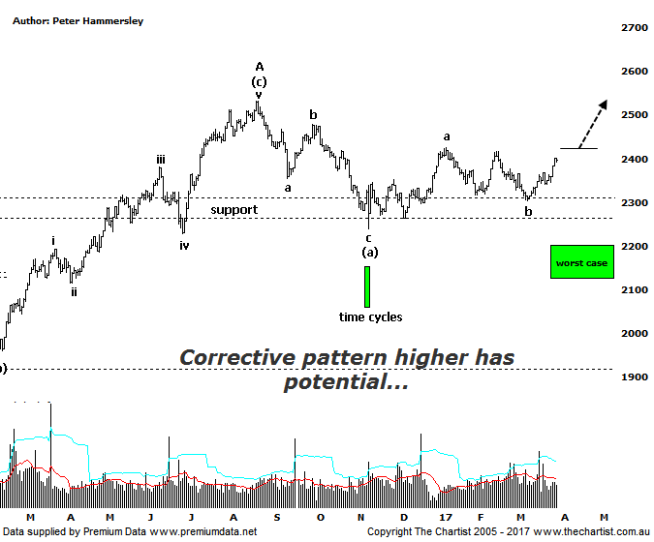

Bottom Line
30/3:
Daily Trend: Down
Weekly Trend: Down
MonthlyTrend: Down
Support levels: 2239 - 2228 / 2201 - 2123
Resistance levels: 2426 - 2479 / 2532
Video Analysis
Watch Video Analysis Here
Technical Discussion
On the face of it our market has been performing well over the past few months, especially from the November 2016 lows with some impulsive price action kicking in. Over the past couple of days buyers have again fronted up suggesting a new trend is in motion, albeit likely only over the short to medium term. In fact, the XAO has rallied over 15% from those November lows made last year. However, the Small Ordinaries (XSO) has only managed a 7% climb which of course is a substantial underperformance. This just reiterates the fact that it’s once again just a handful of the blue chips that have been pushing the broader market higher. Even the mid-cap stocks have been struggling for traction over the past few weeks with many retracing following their strong prior uptrends. This isn’t major reason for concern but it is making for some frustrating trading conditions right here and now. This trait is expected to change although at the moment investors seem happy to chase the likes of the big four banks. Increased investor confidence however will eventually result in some bargain-hunting in many of the minnows - assuming nothing comes out of left field to spook US markets which at the end of the day continue to provide the lead which we dutifully follow.
Reasons to be more optimistic longer term (caution short term):
→ Investors have been taking a “risk on” approach.
→ Outperforming the larger cap stocks over recent months.
→ Price is holding above a zone of support
→ Further stimulus out of China should be bullish for Australian equities.
→ Whilst traders are continuing to chase yield a healthier looking market would increase confidence levels.
→ The beaten down small caps will offer an alternative.
For many months now we have been of the opinion that the patterns on this chart show much more clarity than those within the XJO which is a characteristic that hasn’t changed. However, during our last review of the XSO we also noted that choppy price action was apparent, suggesting that a larger correction was starting to look more feasible with the target area just beneath 2200. However, the latest bounce reduces the risk of getting one final probe down into that aforementioned target zone. As such, we have amended our smaller degree wave count which now suggests the probe down to the upper boundary of the zone of support three weeks ago completes minor degree wave-b with wave-c still in its early stages. Bigger picture, the best interpretation is that the high of wave-A made in August last year is going to be followed by a flat pattern as opposed to a deeper zigzag. This will allow for price to head up toward the prior pivot high at 2532 or even slightly higher before another leg South kicks into gear. This will eventually complete a larger degree wave-B which will set the stage for a multi-month trend higher as a minimum. This is looking much further down the track so we’ll continue to focus on the smaller degree patterns which will ideally continue to show us the way forward. We were looking for our annotated time cycle cluster to trigger an impulsive movement higher although this clearly hasn’t been the case. That said, it has proven to be significant with a rally unfolding since that time cycle was put in place. We’ll continue to be on the lookout for future time cycle ratios and projections as they often result in a trend reversal.
Trading Strategy
We’ve been putting forward plenty of potential breakout trades recently although this doesn’t always incorporate a formal recommendation. One that immediately comes to mind is FXJ which on Monday was on the cusp of breaking through the upper boundary of a large trading range. The breakout was witnessed yesterday with price racing higher intraday only for sellers to come out of the woodwork in high numbers, resulting in a close near the session’s lows. Today has also been poor. This is just one example of many which again advocates caution and draws our attention to the fact that it’s the blue chips that have been in demand with almost everything else struggling for traction. This trait needs to change before we start putting forward formal recommendations in some of the smaller cap stocks.

