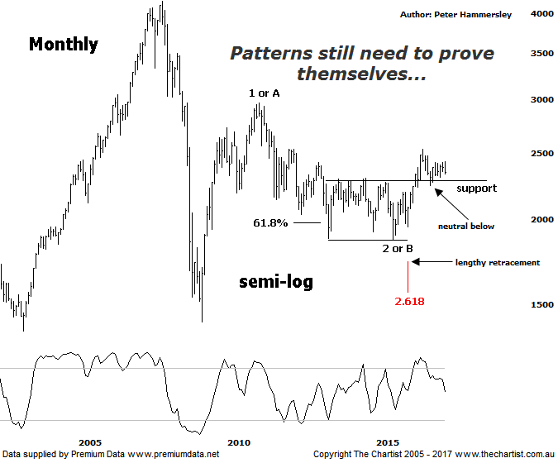

Bottom Line
19/5:
Daily Trend: Down
Weekly Trend: Down
MonthlyTrend: Down
Support levels: 2239 - 2228 / 2201 - 2123
Resistance levels: 2431 - 2479 / 2532
Video Analysis
Watch Video Analysis Here
Technical Discussion
The initial thrust higher in the Small Ordinaries (XSO) from the 2009 lows was just as impressive as the one in the XAO which is a trait you’d expect to continue in a bull market. In fact in the US, stocks have been heading higher in unison which confirms the bull market conditions over there. However, we haven’t been so lucky. Cracks started to appear in August 2011 which is when the broader market resumed its uptrend following the prior corrective phase. The XSO did not join in on this rally and instead continued to head south. Since that time, it’s severely underperformed although it did manage a decent leg higher from the low made in August 2015. Since then, it’s been less than convincing, especially when looking at the larger degree patterns which we’ll do below. The bottom line is, it’s been a lacklustre performance by the smaller cap stocks which confirms our view that a bear market bounce only is unfolding. That’s not to say higher prices can’t be seen both in the XAO and XSO as they can. Whether the latter can play some catch up and trend is the million-dollar question. It can, although if this is to be the way forward then the “risk on” trade needs to commence quickly. If not, then the divergence between the two indexes is likely going to continue which is something we don’t want to see as it limits opportunities.
Reasons to be cautiously optimistic longer term (caution short term):
→ Investors have been taking a “risk on” approach.
→ Matching the larger cap stocks over recent months.
→ Price is holding above a zone of support
→ Further stimulus out of China should be bullish for Australian equities.
→ Whilst traders are continuing to chase yield a healthier looking market would increase confidence levels.
→ The beaten down small caps will offer an alternative.
We must start our wave count from the 2009 lows here with price action difficult to decipher from an Elliott Wave point of view prior to that date. There’s no doubting a strong impulsive leg higher commenced from the 2003 lows which ideally should have been followed by a corrective pattern down. We can see here though that the subsequent leg lower was almost parabolic to the downside. As such, we must expect a countertrend movement higher from the 2009 lows, albeit there’s still scope for significantly higher levels if some traction can be gleaned. The main positive is the strong and impulsive leg higher up to the April 2011 high which is what’s keeping the door open for further strength over the coming years. The subsequent retracement has been choppy and messy in nature which is ideal. However, the pull-back has taken well over twice the time taken by the prior leg higher meaning symmetry is lacking from a time perspective. Wave-2 or B has dragged its heels which means we are entering a period of time where we need to see buyers step up. Remember though, we are looking at the monthly timeframe here so by quickly, we don’t mean over next few days. Should the current consolidation phase resolve to the downside, there is scope to head down to the typical retracement zone of the whole leg higher off the August 2015 lows sitting between 2201 – 2123. However, we’ll look at the smaller degree patterns in a few weeks time via the daily chart. Should the lower boundary of the aforementioned typical retracement zone be overcome a red flag will have been raised with the risk immediately moving to the downside. For the moment though, the more bullish case is hanging in there but only by the skin of its teeth. It still needs to prove itself before getting overly confident.
Trading Strategy
As stated during our last review, more evidence is required before getting aligned to smaller cap stocks. If the broader market can kick higher the minnows do provide an alternative although the “risk on” approach needs to return before getting confident that a leg higher similar to the one seen off the 2009 lows up to the April 2011 highs is going to commence. At the moment, we have a broader market driven by the blue-chip stocks which is a characteristic that needs to change. All that said, if low-risk opportunities present themselves we will present them to you.

