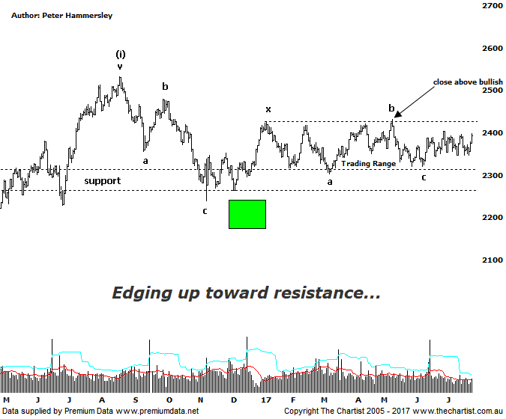

Bottom Line
26/7:
Daily Trend: Up
Weekly Trend: Upzz
MonthlyTrend: Up
Support levels: 23.19 / 2239 - 2228 / 2201 - 2123
Resistance levels: 2431 - 2479 / 2532
Video Analysis
Watch Video Analysis Here
Technical Discussion
It continues to be a frustrating time if you’re involved in many of the smaller cap stocks with price unwilling to trend in either direction for a sustainable period of time. The XSO has undoubtedly been range bound although that range has tightened even further over the past few weeks. Over the years smaller cap companies have severely underperformed the broader market which is usually a sign that a large bear market bounce is unfolding. It’s different in the US where stocks have been moving higher in unison which on the flipside suggests bull market conditions. It’s difficult to envisage the XSO heading higher with a serious degree of attitude unless the XJO can provide a lead. To a large extent this comes down to confidence, or should I say lack of it. Trading conditions have been, and continue to be difficult which in turn puts traders and investors on the back foot. They are less willing to take on added risk. It’s been a better few days for the smaller cap stocks with price heading toward the upper boundary of the trading range although we can’t get overly excited until the breakout finally transpires. Until then, caution is still required.
Reasons to be cautiously optimistic longer term (caution short term):
→ Investors have been taking a “risk on” approach.
→ Matching the larger cap stocks over recent months.
→ Price is holding above a zone of support
→ Further stimulus out of China should be bullish for Australian equities.
→ Whilst traders are continuing to chase yield a healthier looking market would increase confidence levels.
→ The beaten down small caps will offer an alternative.
Our last look at the Small Ordinaries was back in May via the monthly chart. This always takes out a lot of the noise which is never a bad thing when long drawn-out consolidation patterns take hold which of course has been the trait here. This also showed that although price took a massive hit off the late 2007 highs, declining over 66%, the patterns weren’t advocating doom and gloom. In fact, it seemed likely that a larger corrective pattern commenced back in 2011 and completed in August 2015. The bounce off those lows was initially impulsive in nature which is a small step in the right direction. Of course, zooming into the more recent price action shows a lack of direction with a complex combination pattern continuing to form. The problem with these types of complex corrections is that they often continue to become even more intricate which isn’t ideal from a trading point of view. All we can do for now is label the chart as a potential double or triple three. The bottom line is, this could unfold in a number of ways so we’ll concentrate on the upper and lower boundaries of the trading range as a break up or down through either would return some clarity to the patterns. For now, we must simply expect more of the same although at least price is heading toward the upper boundary of the range which provides a chance of something more bullish unfolding. The patterns, and for that matter the broader market still need to prove themselves.
Trading Strategy
As mentioned above, complex combination patterns aren’t the best to trade-off. Having said that, we’ll continue to concentrate on the patterns in the individual stocks themselves as opposed to concentrating too much on the price action shown here. We are currently involved in several smaller cap stocks which have been doing quite well for us over the past few weeks. If more setups present themselves we’ll continue to put them forward for the more aggressive trader. Just be aware that volume can be an issue, with two that we currently hold, CZZ & HUB being testament to that. When they trend though, they tend do so very nicely indeed.

