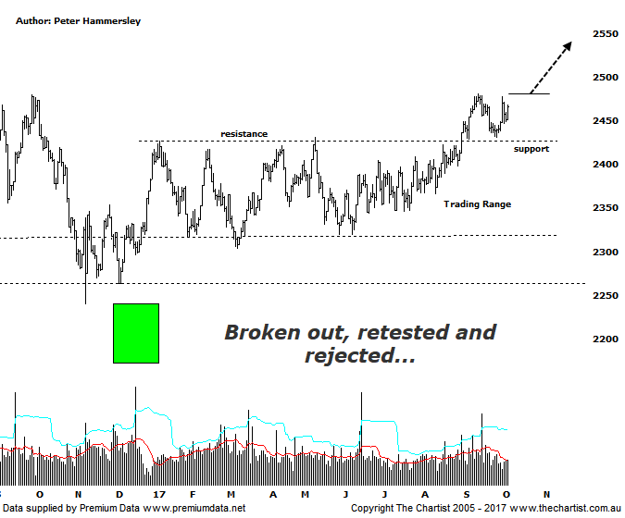

Bottom Line
5/10:
Daily Trend: Up
Weekly Trend: Up
MonthlyTrend: Up
Support levels: 2431 - 24.17 / 2303
Resistance levels: 2532 / 2961
Video Analysis
Watch Video Analysis Here
Technical Discussion
Since the 9th of June low the XSO has gained 6% up to today’s high which although not startling is a decent effort. On the other side of the coin, the All Ordinaries is sitting at almost exactly the same levels as it was back in early June. In other words, the outperformance of the smaller cap stocks continues. It’s not so much that there’s been a rotation out of the market in general, but there’s certainly been a reallocation of funds. The banks were never going to be able to drive the XJO higher forever, as a healthy pause or retracement always materialises. This is what’s transpiring now. Without the help of the big four banks and a couple of other big name blue-chip stocks it’s always going to be a struggle for the broader market to gain momentum. In simple terms, the banks have stalled and this has caused stagnation in the ASX-200. The question is, can the divergence in the two indexes continue? We believe it can, mainly because of the technical picture which has taken a turn for the better over the past month or so. Let’s look at the technicals.
Reasons to be cautiously optimistic longer term:
→ Impulsive price action has developed.
→ The “risk on” approach has returned.
→ Outperforming the larger cap stocks over recent months.
→ Price is holding above a zone of support
→ Further stimulus out of China should be bullish for Australian equities.
→ Whilst traders are continuing to chase yield a healthier looking market would increase confidence levels.
→ The beaten down small caps will offer an alternative.
Although we must go all the way back to August to find our last review of the XSO, we have been including the chart in recent reviews of the XJO. The big development has been the break out of the trading range that commenced in January this year. Quite often price will come back to retest the breakout area which as can be seen here is a box that can be ticked. Also, buyers stepped up at those lower levels just over a week ago which is a positive sign. Another higher high, by the way of price pushing up through the recent pivot high at 2481 would increase confidence levels regarding the recent breakout sticking. From an Elliott Wave point of view there isn’t a great deal to get enthusiastic about although this is often the case when lacklustre sideways price action takes hold for sustainable periods of time. One thing we can say is that price action off the November 2016 low is choppy in nature suggesting current strength is part of a larger corrective pattern. However, as we’ve seen on many charts recently, these larger patterns offer excellent upside potential even within countertrend movements higher. The next area of resistance sits up around 2536 which would be a good hurdle to overcome. If it is, we can start thinking in terms of continuing up to the recovery highs made in February 2011 around 2960. We don’t want to look too far ahead so for now we’ll concentrate on the smaller degree patterns which continue to unfold nicely with further upside potential ahead.
Trading Strategy
As stated in last Friday’s review of the XJO, the smaller cap stocks are looking stronger although this doesn’t necessarily mean we should concentrate all our efforts on that side of market. The cream always rises to the top meaning setups will present themselves when they are good and ready. Some good patterns are developing and ideally a few more setups will be presented over the coming weeks.

