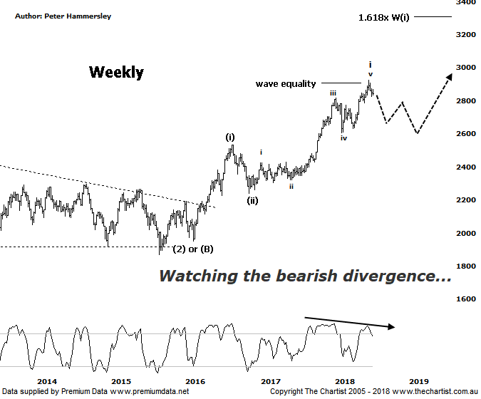

Bottom Line
12/7:
Daily Trend: Down
Weekly Trend: Up
MonthlyTrend: Up
Support levels: 2607 / 2431 - 24.17 / 2303
Resistance levels: 2818 - 2960
Video Analysis
Watch Video Analysis Here
Technical Discussion
From the August 2015 lows the Small Ordinaries (XSO) has been playing catch up which shouldn’t come as great surprise considering the underperformance off the 2009 lows. As long as global equity markets can hold themselves together there’s no reason why this outperformance can’t kick back into gear again further down the track. Over the past few weeks the index has been moving in unison with the XJO, albeit the trend is still up. There are several commentators and analysts suggesting that the good times for the smaller cap stocks has run its course, with the big blue chips next in line for a rally. One thing is for sure, the top 20 have underperformed by a reasonable margin with both the mid-cap & smaller cap stocks outperforming. This doesn’t mean a great deal in itself although we also must factor in the so-called trade war which always has the possibility of turning ugly. Should this transpire then the “risk on” trade is going to be thrown out of the window with funds likely flooding into the perceived safer companies which would likely place the focus on the big banks and Telstra although of course the latter currently has major issues, so we can’t get overly confident in that regard. The conflict between the US and China on tariffs may prove to be a damp squid although of course the market doesn’t like uncertainty and will therefore punish stocks accordingly should things start to get ugly. This could be beneficial for gold over the short-term although looking back in history shows us that the yellow metals “safe haven” tag is largely unfounded.
Reasons to be cautiously optimistic longer term:
→ Impulsive price action has developed.
→ The “risk on” approach has returned.
→ Outperforming the larger cap stocks over recent months.
→ Price is holding above a zone of support
→ Further stimulus out of China should be bullish for Australian equities.
→ Whilst traders are continuing to chase yield a healthier looking market would increase confidence levels.
→ The beaten down small caps offer an alternative.
Our last review was during big picture week meaning our focus of attention was on the monthly chart which showed that the risk was to the upside. Over the longer-term this is still our expectation although price has hit an important juncture on this weekly timeframe. The recent pivot high has tagged the wave equality projection almost to the point before the retracement set in. Just as significant is the Type-A bearish divergence which is something that’s been plaguing our weekly charts for what seems like an eternity although in reality it’s only been a couple of months or so. Still, it’s a nice example here with a deep “V” increasing its significance. It’s also triggered with our indicator starting to head down toward the oversold position although on this timeframe it’s going to take several weeks before it unwinds fully. This doesn’t automatically mean weakness is going to be the way forward, but it usually means that the prior pivot high will not be overcome any time soon. The wave count continues to look bullish with wave-(iii) likely in motion. As mentioned previously, the wave equality projection has been tagged although usually this part of the trend extends which provides a target up around 3311 although the prerequisite is that the prior pivot high at 2923 is overcome before getting overly confident. At larger degree the wave equality projection aligns nicely with the aforementioned higher target providing some confluence. In other words, there’s still a case for positivity over the coming months and even years ahead.
Trading Strategy
As mentioned in last night’s review of the XMJ, we don’t focus on one particular sector as we let the patterns dictate which stocks we get involved with. The same goes here, with no reason to solely focus on either the blue-chips or the smaller cap stocks. The cream always rises to the top meaning we should get involved with the right side of the market. That said, most of our current trades are aligned to the larger cap stocks with the patterns on most still looking bullish.

