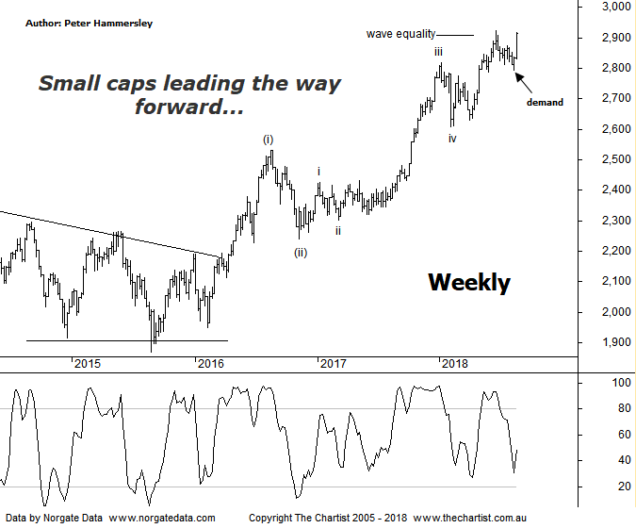

Bottom Line
23/8:
Daily Trend: Up
Weekly Trend: Up
MonthlyTrend: Up
Support levels: 2607 / 2431 - 24.17 / 2303
Resistance levels: 2924 - 2960
Video Analysis
Watch Video Analysis Here
Technical Discussion
Following the strong leg up to the high made on the 21st of June, the Small Ordinaries (XSO) has been taking a breather. In fact, it’s been the blue chips as well as the banks that have been outperforming until recently. However, over the past few days this trait has turned on its head with some of the smaller cap stocks suddenly kicking back into gear with a vengeance. The banks have been putting the brakes on recently which has meant the XJO has been struggling the traction, especially as the big miners have also been stagnant. As suggested in last night’s review of the Banking sector there is room for the big four banks to head lower over the short-term although the longer-term bullish case remains in place. One thing we must appreciate is that US markets are now heading back into blue sky territory following prior weakness meaning confidence is again high. Although this may not flow through to the broader market over here, it could well trigger strength in the second and third tier stocks. It appears that the “risk on” approach has returned which again comes down to positive leads from US markets. For several months now we’ve been running with the theory that the smaller cap stocks have been showing the better, and more bullish patterns. Nothing changes in that regard.
Reasons to be cautiously optimistic longer term:
→ Impulsive price action has developed.
→ The “risk on” approach has returned.
→ Outperforming the larger cap stocks over recent months.
→ Price is holding above a zone of support
→ Further stimulus out of China should be bullish for Australian equities.
→ Whilst traders are continuing to chase yield a healthier looking market would increase confidence levels.
→ The beaten down small caps offer an alternative.
Type-A bearish divergence on this weekly chart was the headwind during our last review and it has proven to be significant, with weakness unfolding over the past few weeks. Technically the divergence is still in place although the recent low in our indicator came within a whisker of tagging the oversold position. If price heads up through the recent pivot high at 2924 it’s likely that the divergence has done its dash. Our wave count remains in place with intermediate degree wave-(iii) taking price higher. However, if we zoom into the more recent price action we can see that another smaller degree 5-wave move appears to be unfolding from the low of wave-iv. In other words, if the minor degree wave count is correct then an interim top isn’t too far away. That said, this doesn’t fit with the larger degree patterns which still have plenty of upside potential left in them. The reason being, wave-(iii) thus far has only just tagged the wave equality projection which is usually the minimum expectation. In stocks the third leg usually extends which means it needs to travel 1.618x the length of wave-(i) projected from the low of wave-(ii). This provides a target up around 3300 from where we’d expect to see a sideways consolidation before further strength. Looking at the price action off the 2009 lows allows for significantly higher levels to be tagged although there is no point getting too far ahead of ourselves at this stage. It would now take a push beneath the low of wave-iv at 2607 to move to a neutral stance and a continuation beneath 2532 to become concerned, neither of which is looking likely at this stage.
Trading Strategy
We have been aligned to the blue chips over the past few months and although this has proven to be fruitful, some of those stocks have started to struggle for traction with BHP being one that immediately comes to mind (we took profits yesterday). That’s not to say patterns have become bearish as they certainly haven’t but it could be a while before prior trends reignite. This could lead us to realigning our portfolio over the coming weeks. As always, we’ll let the cream rise to the top, and if this presents opportunities in the smaller cap stocks then we’ll make a natural transition.

