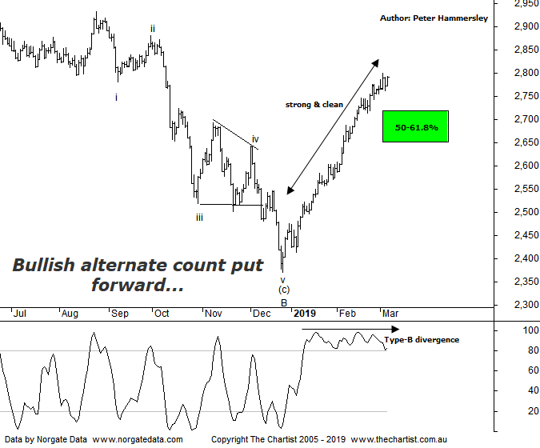

Bottom Line
6/3:
Daily Trend: Up
Weekly Trend: Up
MonthlyTrend: Up
Support levels: 2371 - 2319 / 2266 - 2239
Resistance levels: 2924 - 2960
Video Analysis
Watch Video Analysis Here
Technical Discussion
From the lows made in December last year the Small ordinaries (XSO) has gained around 18% up to the recent pivot high meaning it’s outperformed the XJO which has gained 15%. This reiterates that “risk on” approach from investors. This is a dramatic turnaround in sentiment considering the potency of the trends lower in global equity markets on the run-up to the Christmas period. Bigger picture of course smaller cap stocks have substantially underperformed off the 2009 lows which still haven’t retraced 61.8% of the whole leg down that commenced in November 2007. One would assume that as long as global equity markets remain bullish, then some catch up is on the cards which is good news for those aligned to smaller cap stocks. Our opinion is that we simply let the cream rise to the top meaning we don’t want to focus on one side of the market. If the patterns look bullish and provide low risk entries, it’s immaterial whether it’s a blue-chip stock or a minnow. There are plenty of extremely large companies trending extremely well so we don’t want to be filtering those out. The bottom line is, the market is in rally mode with no indication it’s going to terminate at this stage.
Reasons to be cautiously optimistic:
→ Markets ignoring potential bad news and focusing on positives.
→ Volatility has subdued significantly.
→ A strong impulsive leg higher has kicked in.
→ Perceived headwinds in China starting to wane.
→ Negotiations on trade talks reportedly going well between the US and China.
→ During times of rising prices the “risk on” approach is popular.
Having seen a 5-wave move lower prior to our last review the door was open to head up into the typical retracement zone just above 2700 which was going to be an important juncture if tagged. The good news is that those higher levels have been achieved in quick fashion although more significant is the push up through that potential reversal zone within a strong clean trend. There is some bearish divergence in position on this daily chart although thus far it isn’t proving to be overly significant which is a similar story on the chart of the XJO. We can’t ignore it though as it could still potentially trigger a leg lower although for the moment buyers are in total control. This evening I’m going to put forward an alternate count which is much more bullish. It isn’t perfect, although the straight-line movement higher over the past couple of months means something more bullish medium to longer term could be underway. We’ve put forward a 5-wave impulse lower as completing a larger correction in December of last year which fits better with the subsequent rally which has been extremely potent. One thing is for sure, if price continues with the same trajectory and heads up through the significant high at 2391 then this more bullish labelling of price is likely going to prove itself. In other words, the smaller degree patterns still need to prove themselves but for now that’s exactly what they are doing. As always, it’s highly likely that we’ll see a decent correction at some point but as long as it’s overlapping and corrective in nature the bullish case remains. Although price is looking overbought on both the daily and weekly charts it doesn’t necessarily follow that a retracement is going to kick in immediately. As we’ve seen in US markets, price can remain overbought for significant periods of time.
Trading Strategy
As already mentioned, we don’t align ourselves to one side of the market. We tend to let the patterns do the talking from a trading perspective. Yes, smaller cap stocks have outperformed over the last few weeks although to be fair it isn’t by a significant margin. We’ll continue to put setups forward in the position status page irrespective of sectors or size of the company. One thing is certain, there’s no point being out of this market which continues to perform well.

