ASX-200 Financial Sector ex Property Trusts (XXJ)
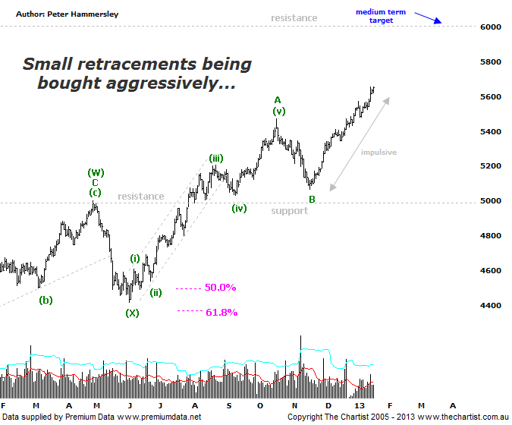
Bottom Line
21/1:
EW Trend: Corrective (?)
Price Trend: Up
Trend Strength: Strong
Video Analysis Watch Video Analysis Technical Discussion
21/1:
LAYMANS:
The Banking Sector has been leading our market higher over recent months which is a trait that continues to be seen. The ideal situation in regard to the patterns was to see a small pull-back following our last review though nothing could be further from the truth. In fact the trend has continued relentlessly in pretty much a straight line move which just emphasises the strength of the sector. It now seems likely that the dip is going to evade us with recent highs heading up through a very important juncture just above 5400. In fact that level was overcome without so much as a blink of an eye with buyers continuing to chase price higher. As we’ve mentioned in previous reviews the attraction here continues to be the yield, especially from the funds. Unless they change tack and look for growth there is every chance that it’s going to be onwards and upwards from here. One thing’s for sure, there is no sign of any selling pressure whatsoever which has pretty much been the case since mid-November. There’s no doubt that the patterns are looking a little stretched though that in itself doesn’t necessarily mean that a corrective phase is imminent.

TECHNICAL:
One aspect of the patterns we always pay close attention to is the time factor. And for very good reason as it either adds weight to the analysis or questions it. In this instance we were looking for a larger flat pattern to evolve from the currently labelled wave-A as it would fulfil our requirements in regard to time taken by the retracement though it’s failed to materialise. As such we’ve had to amend our labelling slightly although over the medium to longer term our targets remain unchanged. Ultimately there is no reason why this trend can’t continue up toward the 6000 region or even slightly above although those heights aren’t going to be achieved overnight. However, they are definitely achievable over the longer time frame. The highest interpretation now is that some form of large combination pattern is taking hold to the upside with plenty of scope for strength over the coming weeks and likely even months ahead. What we are left with now is the recent pivot high completing wave-A with the subsequent retracement into wave-B having completed, despite it lacking slightly in terms of depth and time taken. It certainly hasn’t taken the expected 38.2% of the time taken by the prior trend whilst it’s also failed to hit the typical retracement zone. Although not ideal from a pure Elliott perspective it just reinforces the strength of the trend. At the end of the day buyers are jumping in very early during counter trend moves which exudes confidence and adds weight to the bullish case. Wave-C has certainly taken off like a scalded cat though remember at this stage of the trend impulsive price action should be the main theme so there is nothing out of the ordinary in that department. There is a decent line of resistance running through 6000 making it our focus of attention for the foreseeable future though as already mentioned ultimately it should be exceeded.
Trading Strategy
21/1:
Although it would be ideal to see a nice symmetrical 5-wave subdivision up from the low of wave-B the lack of any decent retracement are now making this unlikely. In itself this doesn’t alter the bullish pattern put forward although it doesn’t help in regard to buying opportunities. The best strategy here is to be on the lookout for small micro consolidation patterns. These could take the form of pennants or flats (which are basically box patterns). At this juncture a low risk entry isn’t available meaning I wouldn’t be inclined to jump on just for the sake of it. If a set-up presents itself then jump on with a view to trading price up toward the annotated line of resistance as a minimum with the potential for even higher levels to be tagged.

