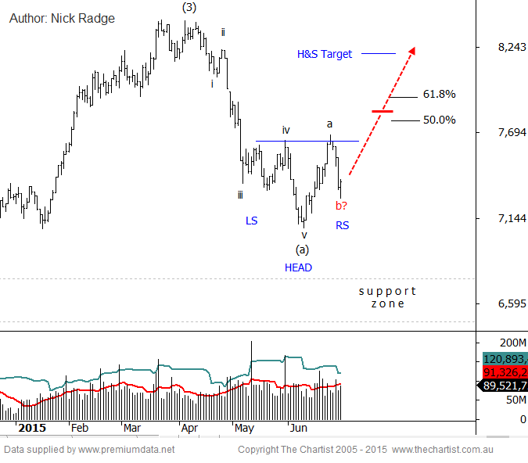

Bottom Line
30/6:
Daily Trend: Neutral
Weekly Trend: Down
Monthly Trend: Down
Support levels: 7084 / 6736
Resistance levels: 7646 / 7752 / 7910
Video Analysis
Watch Video Analysis Here
Technical Discussion
On a relative strength basis this Banking Sector, and a few others, are doing well against the broader indices. There may well be scope here to suggest that the first leg of the larger correction has completed and a renewed upside probe could now unfold. Obviously this will depend on the global situation in the coming weeks, but with the information we have here and the patterns taking shape, a moderate bounce back toward 7700 is probable.
Reasons to be aligned to the Sector longer term:
→ The recent falls in interest rates can only be bullish for the market and the sector as a whole.
→ Interest rates should remain lower for longer due to recent inflation data.
→ The Banking Sector continues to be the driving force behind broader market strength.
→ The longer term trend is exceptionally strong.
The Banking Sector really has been the driving force of the Australian market so it's imperative that we track the pattern progression with an understanding that any shift in the larger term trend here will also pave the way for the broader ASX over the coming year or so. As at writing that larger degree trend remains intact and recent weakness has been a smaller correct maneuver. We're not out of the woods, but tonight we'll focus on some positive patterns to follow in the next few months.
Let's start with the Elliott Wave patterns which are really the cornerstone of these sector reviews. Without argument the retreat off the highs has been impulsive with a distinct 5-wave look and feel. This is good because it allows us to understand where the bigger patterns are at and enables us to trace the expected pattern progression. After every impulse we should expect a 3-wave counter trend retracement, or in this case a bounce. It may well be that todays low is the end of the second wave, the wave-b, and if so we'd now expect wave-c to take prices up toward the larger degree retracement zone between 7700 and 7900. The second pattern of interest, which adds weight to the Elliott Wave projection, is the traditional Head & Shoulders reversal. The proportions of that pattern align well with the preceding trend and the upside target is 8200 - well above the Elliott Wave target zone. A bounce above the Elliott Wave zone and on toward the H&S target would bode well for the longer term trend, remembering we're in a wave-4 which tends to be a broader consolidation pattern rather than a deeper corrective pattern. That said, we do not expect new highs anytime soon and certainly do not expect any sustainable trend to take shape.
Trading Strategy
With the patterns at hand, and the expected outcome discussed above, the best opportunities are for swing traders at this stage. An aggressive stance would be buying right here with stops below 6750. Alternately buy partial positions here and add once the necklines of the H&S has been penetrated. Also keep an eye on the Dividend Momentum strategy. We're coming into an earnings period and if momentum does start to pick up then there could be some solid opportunities therein.

