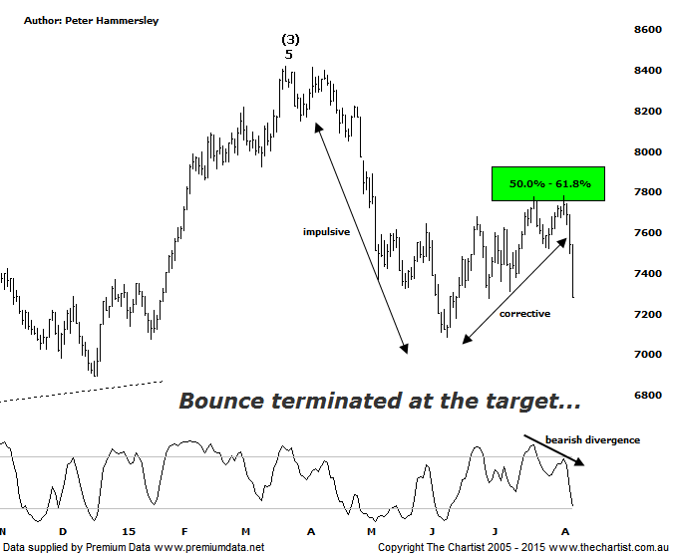

Bottom Line
7/8:
Daily Trend: Down
Weekly Trend: Down
Monthly Trend: Down
Support levels: 7084 / 6736
Resistance levels: 7781 / 7910 / 8419
Video Analysis
Watch Video Analysis Here
Technical Discussion
After yesterday’s news regarding ANZ and their capital raising for $3.0 billion it’s probably a good time to revisit the Banking sector. We’ll get into the technicals below though suffice to say, price action since Tuesday has been an eye opener to say the least. Funnily enough price is still higher than it was during our last review though that’s of little consolation if you’ve been holding the big four banks over the past few days. We won’t go into the details of yesterday’s news as it was well documented in last night’s review of ANZ. Rumours today have been rife with one being that CBA is about to raise $10 billion although it’s worth reiterating that this is totally unsubstantiated and definitely wasn’t from a trustworthy source. One thing’s for sure, the banks are now under pressure with many investors and analysts asking the question as to whether they are overvalued. ANZ’s June quarter profit result announced yesterday also fell short of expectations which hasn’t helped; it was also assumed that the bank was going to avoid a capital raising by selling off assets which was managements preferred strategy. Not to be.
Reasons to be aligned to the Sector longer term:
→ The recent falls in interest rates can only be bullish for the market and the sector as a whole.
→ Interest rates should remain lower for longer due to recent inflation data.
→ The Banking Sector continues to be the driving force behind broader market strength.
→ The longer term trend is exceptionally strong.
During our last look at the index there was every expectation that a bounce was going to take price up into the typical retracement zone which is now a box that can be ticked. There was an outside chance that the H&S target just short of 8200 was going to be achieved although this is now looking highly unlikely. Technically speaking the H&S pattern is still in position though as far as we’re concerned it’s pretty much invalidated. The main thing to take away from this chart now is that our target has been tagged and rejected with some force which tells us all we need to know. From the high of wave-(3) made back in March of this year a very strong impulsive leg down has been followed by a choppy and messy movement higher meaning our analysis is still firmly on track. In fact we couldn’t have asked for anything more from a pure pattern perspective with the smaller degree patterns playing out very nicely. If an interim top is in position, which seems likely, there is scope for another leg down similar in length to the one seen between the 27th of March and the 12th of June this year. The wave equality projection actually sits at 6446. There is also plenty of confluence at those lower levels which consists of the 38.2% retracement level of wave-(3) and wave-4 of one lower degree; a retracement within wave-(4) quite often terminates in that area. The problem here though is that if we do see those lower levels tagged reasonably quickly then symmetry from a time perspective is way off the mark. As an example, wave-(2) (not shown) took 69 weeks to complete which is the minimum we’d expect of the current retracement. This brings us back to the possible large flat pattern or triangle scenario we’ve been talking about over the past few months. Should either of these take hold price is basically going to meander sideways for the foreseeable future although there will be tradable legs within such a large consolidation pattern.
Trading Strategy
I wouldn’t be looking for a trade in either direction right here and now due to the increased volatility over the past few days. Should a lacklustre low volume bounce unfold then yes, we can start looking for a shorting opportunity but until this transpires the best place to be is on the sidelines which is exactly where we’ve been over the past few months. There is talk that a change of the guard is upon us with the Materials sector likely to outperform over the coming months. This is certainly feasible although looking at the chart of the XMJ it’s very evident that price needs to prove itself which at this juncture it simply isn’t doing. The bottom line is that caution is still required within this sector.

