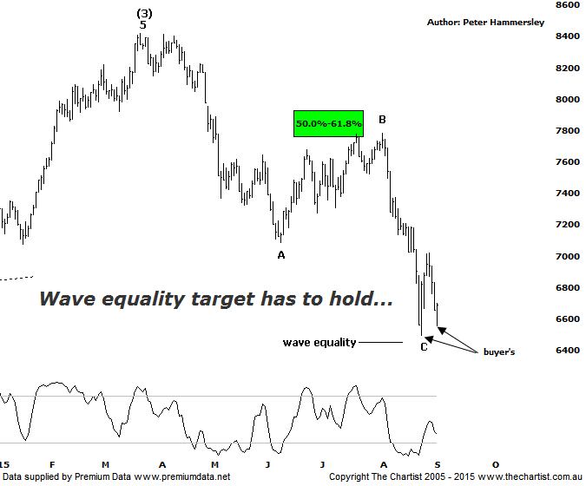

Bottom Line
2/9:
Daily Trend: Down
Weekly Trend: Down
Monthly Trend: Down
Support levels: 6446 / 5878
Resistance levels: 7781 / 8419
Video Analysis
Watch Video Analysis Here
Technical Discussion
We took a look at the bigger picture outlook during our review last week via the weekly chart which showed that we were in a position to see a decent bounce. This duly kicked into gear although it didn’t take long for weakness to reappear. In fact selling pressure over the past few days has been relentless with the significant low made on the 25th of August again coming under pressure. There is room for slightly lower levels to be tagged which we’ll discuss in the technical section below although we have to say this latest bout of selling is less than ideal in regard to our wanted bounce. Continued negative data of China is being blamed as the reason for the rout in commodities although the Banking sector hasn’t fared any better over more recent times. One thing’s for sure, our market continues to steadfastly refuse to stand on its own two feet and is happily taking any negative cue it can find to head south which isn’t a great characteristic to have. It’s now crunch time although what the trigger is going to be for a strong reversal higher is anyone’s guess as nothing is obvious at this stage.
Reasons to be aligned to the Sector longer term (caution short term):
→ The recent falls in interest rates can only be bullish for the market and the sector as a whole.
→ Interest rates should remain lower for longer due to recent inflation data.
→ The Banking Sector continues to be the driving force behind broader market strength.
→ The longer term trend is exceptionally strong.
→ Price has entered a potential reversal zone.
Having hit the target zone and rejected just prior to our last review the ideal situation was that wave-A was in position, portending a decent bounce. This is still feasible though it’s looking less likely having seen the depth of the retracement over the past three or four days. The saving grace could be the wave equality projection at 6446 which is now within touching distance. A probe beneath that aforementioned make or break level would be reason for concern as it would open the door for a much more bearish 5-wave structure to unfold off the March highs made this year. Theoretically our wave count will remain intact until the high of a much larger degree wave-(1) at 5825 is penetrated. The reason being that wave-(4) can never enter the price territory of wave-(1) meaning it’s another critical juncture should the sell-off continue. However, a deep corrective pattern within wave-(4) is extremely rare as they usually tend to be flats or triangles. In other words, the bottom line is that the “smart money” needs to show itself pretty much immediately otherwise it could be a long hard slog for the Banking sector over the coming months which will inevitably pull the broader market down with it. Type-A bullish divergence is still evident on the weekly time frame (not shown) although it still hasn’t triggered. If it can trigger then the picture will become much brighter over the coming weeks although at this stage it appears to be a big “if”. Restraint is still required.
Trading Strategy
As stated above, our wanted longer term bounce is looking a little shaky to say the least so if you’re involved in some of the bank’s (we currently hold CBA) being aggressive with the trailing stop isn’t a bad idea. The trick is not to let a small loss morph into a large one. As long as we continue to use this strategy and let winners run we’ll be successful over the longer time frame. Having said that, there is still absolutely nothing wrong with standing aside over the short-term with the surge in volatility making placement of stops extremely difficult.

