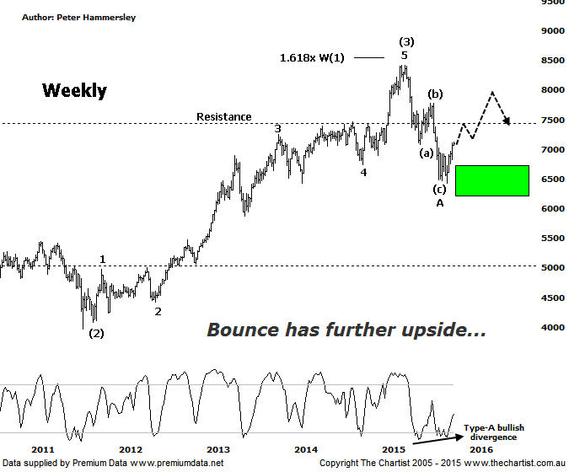

Bottom Line
27/10:
Daily Trend: Up
Weekly Trend: Up
Monthly Trend: Down
Support levels: 6423 / 5878
Resistance levels: 7781 / 8419
Video Analysis
Watch Video Analysis Here
Technical Discussion
Over the past few months we have been noting the better performance of the Materials Sector which has been a step in the right direction for those involved with the Miners. However, that trait hasn’t lasted too long which is reiterated by the fact that since the 12th of October the Banking Sector shown here has gained almost 3% with the Materials Sector declining by a similar amount. Not a huge difference but we also have to consider that this characteristic has been firmly in position for several years. The bottom line is that the likes of BHP & RIO have remained subdued and clearly haven’t been the place to park money. Right here and now this remains the case. Comparing the two charts of the two sectors shows a stark contrast with the XXJ patterns continuing to look bullish longer term. Let’s take a look why this is the case.
Reasons to be aligned to the Sector longer term:
→ The recent falls in interest rates can only be bullish for the market and the sector as a whole.
→ Interest rates should remain lower for longer due to recent inflation data.
→ The Banking Sector continues to be the driving force behind broader market strength.
→ The longer term trend is exceptionally strong.
→ Price has entered a potential reversal zone.
The best patterns by far are evident on the weekly chart which is where we’ll concentrate our efforts this evening. First of all I want to go all the way back to 2009 which is where a 5-wave impulse commenced. This was followed by a nice looking A-B-C corrective pattern which preceded an impulsive leg higher and terminated very close to the 1.618 projection of wave-(1) which is a very common occurrence within a third leg. The interesting development since our last review has been the clear rejection from the wave equality projection which is very important in regard to the larger degree patterns. Equally significant has been the recent move up through the low of wave-(a). The reason being that overlap has now occurred which reduces the chances of a longer term impulsive movement lower unfolding. The bottom line is that from an Elliott Wave point of view we couldn’t really ask for too much more. One thing I have been mentioning a lot over the past few months is that the time taken by the retracement off the March 2015 highs doesn’t show symmetry with the prior retracement into wave-(2). If anything wave-(4) will take longer and will usually be a more complex structure. This brings us back to the triangle scenario or even a larger flat pattern. The prior has a greater chance of unfolding although both patterns portend high prices over the coming weeks and likely months ahead. At this stage I have penciled in wave-A which means the current bounce within wave-B should take price up toward 8000 which is still a large percentage gain from current levels. If the flat pattern proves to be the path taken then recovery highs should be revisited. Just remember that we are looking at the weekly time frame here meaning upper targets aren’t going to be achieved overnight. For now though the wave structures continue to show clarity.
Trading Strategy
In our recent review of Westpac we stated “…Banks are now back on the watchlist though…”. Looking at the patterns here just reiterates why we need to remain on the lookout for low risk entries in the sector. It’s also worth mentioning that bullish divergence on this weekly time frame has now triggered which can only provide us with a tailwind. It’s not a guarantee of higher prices but it usually means the prior pivot low will not be overcome until our oscillator reaches the overbought position; on this timeframe that’s not going to happen for several weeks.

