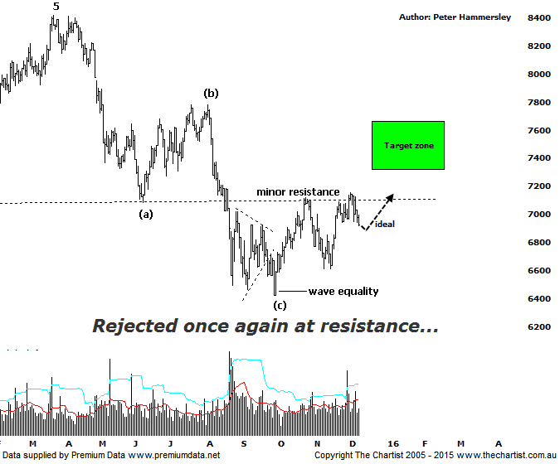

Bottom Line
9/12:
Daily Trend: Down
Weekly Trend: Up
Monthly Trend: Down
Support levels: 6423 / 5878
Resistance levels: 7152 / 7781 / 8419
Video Analysis
Watch Video Analysis Here
Technical Discussion
The banks are at almost exactly the same levels now as they were during our last review back in late October. This is the main reason we haven’t taken a look at the Banking sector over the past few weeks as in reality not too much has changed. This will no doubt be frustrating for some but as we’ve said many times over the past few months, the big four banks are likely only in correction mode, albeit there is still upside potential even within a counter trend movement higher. It’s also worth considering that the banks continue to outperform the Materials sector which we took a close look at last Thursday. To emphasize the divergence between the two sectors it’s worth noting that since the 12th of October this year the XMJ has declined around 23% to today’s low which is highly significant to say the least. In contrast, the banking sector is sitting at exactly the same levels which although not great is a substantial outperformance. This characteristic is showing no signs of abating.
Reasons to be aligned to the Sector longer term:
→ The recent falls in interest rates can only be bullish for the market and the sector as a whole.
→ Interest rates should remain lower for longer due to recent inflation data.
→ The Banking Sector continues to be the driving force behind broader market strength.
→ The longer term trend is exceptionally strong.
→ Price has entered a potential reversal zone.
We all know by now that the banks have been the place to be for dividend yield which actually is still the case. Commonwealth Bank for example (our pick of the bunch) still offers over 5% with ANZ offering a whopping 6.7%. However as usual it isn’t quite that simple. The issue is whether dividends are going to be reduced. Reasons vary from company policy to the pay-out ratio to name just two. That’s enough of the fundamentals so let’s take a look at the technical picture. The weekly time frame shows the clearer patterns although this evening we will look at the smaller degree structures and see what lies ahead over the coming weeks. As mentioned above we are looking for a bounce only although at much larger degree. The wave equality projection sits at 7310 and would be our minimum expectation. That level shows very good confluence with the 50%retracement level of the whole leg down from the all-time highs made in March of this year. However, our highest expectation over the past few months has been to see a triangle or flat pattern which would result in the bounce being extended, up toward 8000 in the triangle scenario and even all-time highs for the flat correction. Both offer plenty of upside from current levels although for now we’ll just have to take one step at a time and see what transpires at the wave equality projection. On the downside, there would need to be a push beneath 6609 to invalidate our analysis.
Trading Strategy
The bullish divergence mentioned on the weekly chart last time is still in play although our oscillator has almost reached the overbought position meaning the tailwind is starting to die out. It’s always worth noting that divergence doesn’t always trigger a leg higher or lower with a sideways meander (as in this case) more than feasible. If you want to be involved it may be a wise to wait until the minor line of resistance is overcome before jumping aboard. We’d then expect a continuation up into the target zone with the aforementioned triangle scenario offering even higher levels over the medium term.

