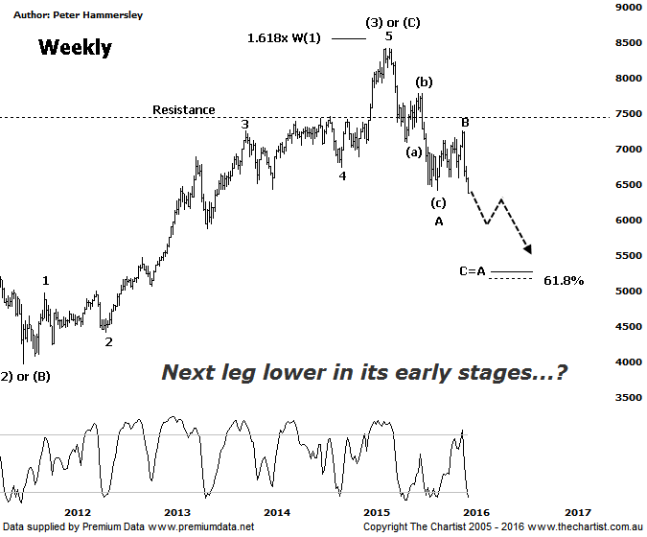

Bottom Line
21/1:
Daily Trend: Down
Weekly Trend: Down
Monthly Trend: Down
Support levels: 5949 - 5878
Resistance levels: 7254 / 7781 / 8419
Video Analysis
Watch Video Analysis Here
Technical Discussion
We’ve been looking for a bounce only in the Banking Sector and not the start of something much more bullish longer term. Although our wanted rally kicked into gear very nicely priced just failed to hit the typical retracement zone by a small margin. This isn’t major reason for concern but it does now suggest that an interim top is firmly in position. As can be seen, over the past three weeks or so price action has been impulsive in nature to the downside which implies there’s further pain to come before a major low is locked in. Whilst most people’s focus of attention is on commodities due to the continued severe sell-off in the price of oil, the Banks have been taking a backseat. However, we have to remind ourselves that it’s been the likes of Commonwealth Bank that have been pushing the XJO higher over the past few years. This characteristic stopped a long time ago which means strength is going to have to come from elsewhere. We also take a look at the Materials Sector this evening although suffice to say there’s little sign of demand and it’s extremely difficult to envisage the likes of BHP pushing the broader market higher any time soon.
Reasons to be aligned to the Sector longer term:
→ The recent falls in interest rates can only be bullish for the market and the sector as a whole.
→ Interest rates should remain lower for longer due to recent inflation data.
→ The Banking Sector has been the driving force behind broader market strength.
→ The longer term trend is exceptionally strong.
The larger triangle that we’ve been talking about over the past few reviews is now looking more unlikely. The reason being that price has just broken down through the significant lower made in October of last year which could well mean that another leg South is in its early stages. Rather than seeing a more bullish flat pattern the odds of a regular zigzag unfolding have increased significantly. The implications of this is that our wanted 5-wave movement higher off the 2009 lows is also looking more unlikely. Assuming an interim top is in position (which seems likely) a continuation down to the wave equality projection sitting at 5258 could unfold. This would mean the high of wave-(1) will be exceeded which is something that can never happen within a 5-wave movement. As such, there is now a strong chance that a corrective pattern higher of those 2009 lows has been witnessed. The wave equality projection just mentioned shows very good confluence with the 61.8% retracement level of the whole leg higher to the all-time highs made in March of last year. As a general rule of thumb, the more confluence we have, the greater the chance of the target area being hit. This also adds weight to the case for another leg South to complete a much larger corrective pattern off the highs made early last year. Of course this does mean there’s now the potential to see a decent percentage fall from current levels and no doubt many will be suggesting Armageddon is upon us. We see it slightly different; a much deeper retracement offers an excellent buying opportunity, albeit further down the track.
Trading Strategy
Last week we took a look at the larger timeframes of all of the big four banks. The key message out of those reviews was that price has been heading higher within a larger corrective pattern with no indication that the longer term uptrend was kicking back into gear. If anything, the patterns have taken a slight turn for the worse and one has to assume that if the XJO is going to embark on a deeper retracement then the banks are going to do exactly the same. Many analysts and traders have become very aware that the enticing dividend offered by the banks is likely going to be reduced. This hasn’t been helping those companies and as an example, one unnamed large broker is suggesting that ANZ is going to cut its dividend to 15.5 cents for the full year. The bottom line is that caution is required.

