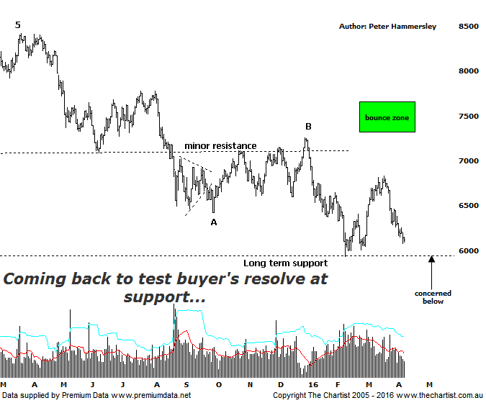

Bottom Line
11/4:
Daily Trend: Down
Weekly Trend: Down
Monthly Trend: Down
Support levels: 5934 - 5878 / 5766 / 5140
Resistance levels: 7254 / 7781 / 8419
Video Analysis
Watch Video Analysis Here
Technical Discussion
The Banking sector definitely hasn’t been the place to be over the past few weeks which is actually true worldwide and not just within our local market. ANZ has especially been affected with impulsive price action lower kicking into gear once more which is definitely not indicative of a more substantial bounce unfolding any time soon. As far as we’re concerned CBA continues to be our favored company although even then, there’s no compelling reason to go out and buy right here and now. At the end of the day the banks are only retracing part of the substantial rally off the 2009 lows which in the bigger scheme of things is only to be expected. Of course with such a high weighting to the Index, if the banks decline then the XJO is going to do exactly the same. True, the Materials sector has been showing a little more resilience though certainly not enough to counteract the decline of the big four banks. One problem being discussed by many analysts is APRA’s paper on funding ratios requirements. It’s reported that only CBA meets the requirement amongst the big four with the others needing to raise significant capital.

Reasons to be aligned to the Sector longer term (Caution short term):
→ The recent falls in interest rates can only be bullish for the market and the sector as a whole.
→ Interest rates should remain lower for longer due to recent inflation data.
→ The Banking Sector has been the driving force behind broader market strength.
→ The longer term trend is strong.
We’ve been concentrating on the larger degree patterns via the weekly chart of late as it shows the clear patterns. However, the larger degree structures haven’t changed so we’ll flip down to the daily chart this evening to see what it reveals. As mentioned last time, overlap has now occurred which means we can no longer see a more bullish 5-wave movement higher off the 2009 lows. Not ideal of course though we can’t ignore what the chart is trying to tell us - we’ve seen a corrective pattern higher and as such it opens the door for a deeper retracement. The typical retracement zone as annotated sits between 5766 - 5140 with the wave equality projection aligning with the 61.8% retracement level suggesting the deeper retracement is more than feasible. In normal circumstances we’d be highly confident of attaining those lower levels, especially from an Elliott Wave perspective. In this instance though, we have a long-term zone of support to contend with which as can be seen on this daily timeframe has attracted buyers in the past. In fact, the latest probe down to the 6000 region resulted in a bounce coupled with a large increase in volume which is something that cannot be overlooked. Indeed, if volume increases at those lows again it could well be that the zone of support is going to be more significant than the wave count which means the deeper retracement could be avoided. At the moment, it could really go either way meaning we need to be vigilant to how price reacts at those slightly lower levels - assuming they’re going to be tagged although this does look highly likely.

Trading Strategy
If we are looking for positives at least the retracement off the highs made in March of last year has been choppy and messy in nature meaning something much more sinister is unlikely to unfold. As mentioned above, the worst-case scenario is to head down into the typical retracement zone which still offers a decent percentage decline from current levels. As such, we have to remain extremely cautious over the coming weeks and months, especially if the zone of support gives way. If you are aggressive and are a believer in the banks you could accumulate partial positions following signs of strength around the zone of support circa 6000 - 5900 although as previously stated, our preferred exposure to the sector remains CBA, especially over the longer timeframe.

