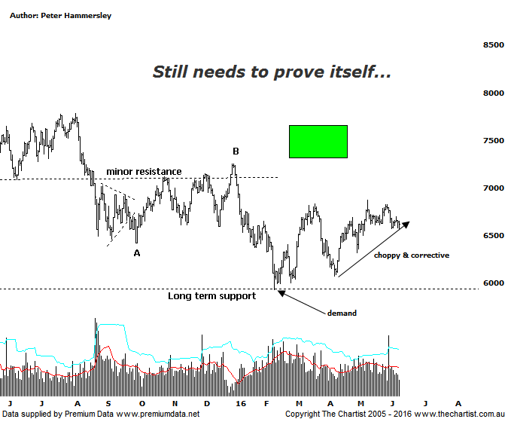

Bottom Line
9/6:
Daily Trend: Down
Weekly Trend: Up
Monthly Trend: Down
Support levels: 5934 - 5878 / 5766 / 5140
Resistance levels: 7254 / 7781 / 8419
Video Analysis
Watch Video Analysis Here
Technical Discussion
We have to go all the way back to early April to find our last review of the Banking Sector where price was hovering above a long-term zone of support. Some headway has been made over the past couple of months but it’s hardly been startling with choppy messy price action continuing to reign supreme. This of course is a far cry from the trend up to the all-time highs made in March 2015. Even accounting for the recent bounce price is still around 22% off those highs and the way the patterns are looking there’s no indication that those higher levels are going to be tested any time soon. There has been a rotation into the smaller cap stocks with the Materials sector also gaining a much better head of steam this year thus far. It’s also worth remembering that the Banking sector makes up around 40% of the XJO so without these financials joining in on the rally it’s very difficult to envisage the index trending smoothly higher. Not impossible, but it adds a lot of weight around the shoulders of companies like BHP & RIO which to be fair also haven’t been performing particularly well. Logically, and taking a look at the price action in the banks in the US suggests that interest rate increases are positive for the sector as a whole. In other words, if the U.S economy starts to pick up, with growth improving then it should have a positive knock-on effect in the big four banks over here. The big question on many analyst’s lips is whether the recent US jobs numbers are a one-off outlier or the start of a trend. Ideally it will be the prior.

Reasons to be aligned to the Sector longer term (Caution short term):
→ The recent falls in interest rates can only be bullish for the market and the sector as a whole.
→ Interest rates should remain lower for longer due to recent inflation data.
→ The Banking Sector has been the driving force behind broader market strength.
→ The longer term trend is strong.

Although it’s difficult to call it a major positive, the long-term zone of support has proven to be significant with buyers stepping up at those lower levels around 6000. Not that the subsequent rise has been strong and impulsive in nature but it does suggest that the zone of support is going to hold, with downside being limited from a technical perspective. One thing is for sure, it would take something coming out of left field fundamentally to envisage a major sell-off within the sector meaning it’s not something to concern ourselves with at this point in time. Looking at the chart shows that price has also come within a whisker of tagging the 50% retracement level of the whole prior trend higher which is a logical place for a reversal higher to kick into gear. However, as discussed above, impulsive price action certainly hasn’t been the way forward which is why we can’t move to a firmer bullish stance at this juncture. Undoubtedly, the recent show of resilience could continue though our expectations in regard to seeing a bounce only haven’t changed. Statistics can be misleading but it is worth pointing out that since the beginning of February the XXJ has rallied just 5% with the XMJ gaining 37% during the same period. The longer term charts show a much different story but of course we are trading the present and not the past. As such we’ll continue to align ourselves to the better performing sectors and sections of the market.
Trading Strategy
“…The worst-case scenario is to head down into the typical retracement zone which still offers a decent percentage decline from current levels. As such, we have to remain extremely cautious over the coming weeks and months…” Nothing changes with caution still required within the sector. It’s been an awfully long time since we’ve wanted to be involved in the likes of CBA which of course is our favoured bank. There’s still no compelling reason to be looking for an opportunity although of course we’ll continue to keep close tabs on the smaller degree patterns as these will be the first clue in regard to something more bullish taking hold. For now though, there are plenty of stocks starting to trend and even busting higher out of reversal patterns which is where our focus of attention needs to be.

