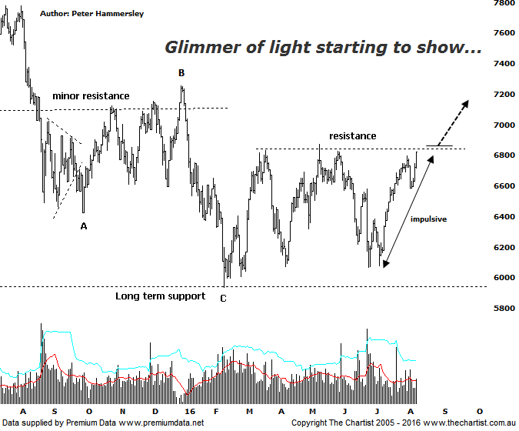

Bottom Line
9/8:
Daily Trend: Up
Weekly Trend: Up
Monthly Trend: Down
Support levels: 5934 - 5878 / 5766 / 5140
Resistance levels: 6874 / 7254 / 7781 / 8419
Video Analysis
Watch Video Analysis Here
Technical Discussion
We haven’t wanted to be involved in any of the banks for many months now although during our last review of ANZ around a week ago we noted price had broken through the upper boundary of a large triangle which was a step in the right direction, albeit further evidence was required that a trend reversal was kicking into gear. Today’s trading update gave the company, and for that matter the sector a boost though whether it’s going to trigger something even more bullish is open to debate. There are still concerns within the sector for a number of reasons. First of all, mortgage rates are extremely competitive with no early indication that margins are going to recover significantly any time soon. We also have to remember that cash rates are likely to remain subdued for the foreseeable future. The bottom line is that earnings are unpredictable and as we know, the market doesn’t like unpredictability. For now, though, the sector is embarking on a rally which could provide some opportunities.

Reasons to be aligned to the Sector longer term (Caution short term):
→ should credit conditions deteriorate further there is a real chance of central banks intervening.
→ The recent falls in interest rates can only be bullish for the market and the sector as a whole.
→ The Banking Sector has been the driving force behind broader market strength from 2009.
→ The longer term trend is still up.

Although we certainly can’t get carried away in regard to today’s rally within the sector the smaller degree patterns have been looking much more robust of late. In fact, since the 6th of July price has rallied over 17% up to today’s high which isn’t a bad effort all things considered. It’s also worth noting that today’s strength has taken price within a whisker of a minor line of resistance meaning an important juncture is upon us. A continuation up above 6874 would be positive and set the stage for the recent leg higher to continue over the coming weeks and possibly even months ahead. One thing we can’t afford to see is a fakeout which is a pattern that has plagued us over the past few years. This is where price breaks up through a line of resistance only to falter immediately and return back into the trading range. It’s a nasty pattern but it hasn’t been cropping up as often over the past few months which is definitely a step in the right direction in regard to trends being more sustainable. The problem when looking at this chart is the potential for some bearish divergence which is likely going to materialise should price break up through the line of resistance immediately. Price will have made a higher high with our oscillator likely failing to confirm by making a lower high. It’s not major reason for concern right here and now but we’ll need to keep a close eye on our oscillator over the coming days. It’s also worth remembering that the Materials sector has been the outperformer having gained 45% of the low made on the 20th of January this year. The Banking sector has only managed just over 6% during the same period.
Trading Strategy
There is undoubtedly signs of life returning within the sector but we are still hesitant to get involved, albeit there is reason for more aggressive traders to dip their toes in, as recently stated in our reviews of both ANZ & BOQ. Over the past few years our preferred exposure to the sector has been with CBA and there’s no reason to change our stance longer term. That said, ANZ is leading the way at the moment with the smaller degree patterns on that particular chart looking a little more advanced as well as being slightly more bullish. We’ll be keeping a close eye on the patterns here on in as it may finally be time to have some exposure to the sector.

