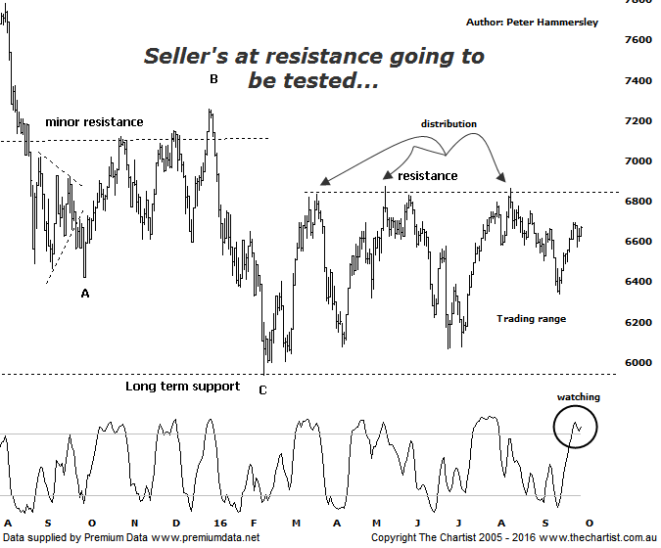

Bottom Line
29/9:
Daily Trend: Up
Weekly Trend: Up
Monthly Trend: Up
Support levels: 6066 - 5934 / $5766
Resistance levels: 6874 / 7254 / 7781 / 8419
Video Analysis
Watch Video Analysis Here
Technical Discussion
There’s no doubting the fact that the banks have been looking stronger since late June but progress has been slow. In fact, since the beginning of the year the banking sector as a whole has lost just over 6% to today’s high point which highlights the underperformance. As always, we’ll take a look at the technical picture below although fundamentally investors are also being extremely cautious. Regulatory changes have been well documented recently although it still begs the question as to whether Australia’s banks need to raise more capital. Analysts remain split on this question although the one thing the market doesn’t like is uncertainty which is exactly the situation. Lower rates put pressure on interest margins and with competition still strong between the “big four “ it’s not difficult to see why money has been moving out of the sector. Higher capital requirements are also viewed as a headwind that’s unlikely to dissipate any time soon. Then we have the continuing saga of Deutsche Bank which is mentioned in the press on a daily basis. A housing bubble is also on many people’s lips adding weight to the despondency. The main reason for mentioning this is because when everybody is bearish and advocating doom and gloom it’s normally a time to be looking at the other side of the trade. I’m not sure we are quite at extreme levels of negativity yet though we must be getting close.
Reasons to be aligned to the Sector longer term (Caution short term):
→ A quarter of a century of economic growth suggests the economy is not about to implode.
→ Should credit conditions deteriorate further there is a real chance of central banks intervening.
→ The recent falls in interest rates can only be bullish for the market and the sector as a whole.
→ The Banking Sector has been the driving force behind broader market strength from 2009.
→ The longer term trend is still up.
Although we can’t totally discount the possibility of heading down into the typical retracement zone of the whole leg higher off the 2009 lows sitting between 5766 - 5140 it’s not looking likely at this juncture. The reason being, there is a very strong zone of support just beneath 6000 which continues to bring out the buyers. CBA is in exactly the same situation and has also bounced strongly off a multi-year zone of support. That’s not to say we jump in all guns blazing expecting another multi-year impulsive trend higher to kick in but at least it suggests downside is limited. Zooming into the more recent price action shows that price is drawing closer to a line of resistance just above 6800 which could hold a few sellers. One thing is for sure though, a push up through 6874 would open the door for a decent trend higher to develop with 7500 not out of the question. This is the measured move out of the basing pattern and would be a high probability target area. First of all though, the breakout needs to materialise which is by no means set in stone. The broader market continues to show strength although over more recent times it’s been the Materials sector (refer yesterday’s review) which has been the driving force behind the move. This trait is expected to continue which again advocates caution in regard to getting overly aligned to the banks. We also have to consider that there has been a shift in sentiment with many analysts becoming much more positive on commodity prices which has been the driving force behind many of the miners.
Trading Strategy
Out of 11 open positions we don’t have any exposure to the banking sector although this hasn’t been a deliberate action. We often state on these pages that the cream usually rises to the top which in essence means we put forward opportunities when the more bullish patterns present themselves. There simply hasn’t been a lot to get excited about in regard to the banks recently although recent reviews of the big four have turned more bullish, at least over the short-term with ANZ leading the way. Should low risk entries present themselves in the sector we’ll put them forward but just remember that the larger degree patterns still need to prove themselves before getting overly optimistic.

