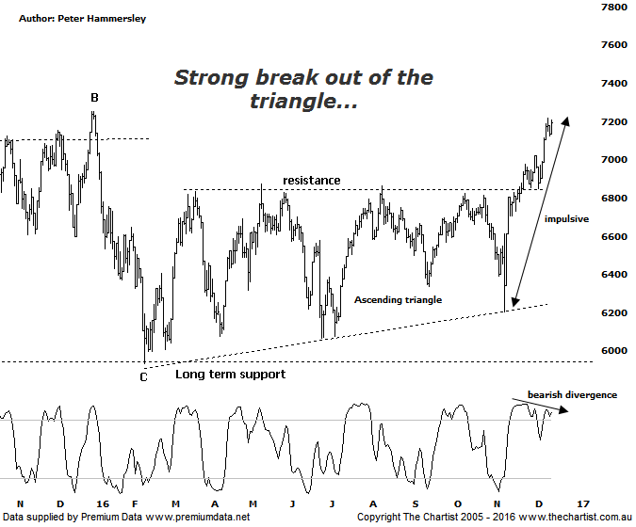

Bottom Line
14/12:
Daily Trend: Up
Weekly Trend: Up
Monthly Trend: Up
Support levels: 6066 - 5934 / 5766
Resistance levels: 7254 / 7470 / 8419
Video Analysis
Watch Video Analysis Here
Technical Discussion
The banks have been out of favour since early last year although when we consider the stellar rise off the 2009 lows it’s not overly concerning. In fact, even down to the pivot low made in February this year, less than 50% of that prior trend was taken back. That’s not to say further weakness won’t be seen next year although for the moment our wanted rally is kicking into gear very nicely. We stated last time that the big four banks account for around 25% of the XJO so they alone have a strong influence on where the broader market heads. The consensus from analysts is that the “Trump factor” is going to be good for world equity markets and even positive for banks. In a high growth environment one would assume that miners will continue to do very well although as always, a balanced portfolio is a necessity. There’s a lot of talk around a transition to growth stocks although this doesn’t necessarily mean that the high yield players (like the banks and Telstra) don’t have their place. After franking, the big four are offering around 7% which is nothing to be sneezed at.
Reasons to be aligned to the Sector:
→ A quarter of a century of economic growth suggests the economy is not about to implode.
→ Should credit conditions deteriorate further there is a real chance of central banks intervening.
→ The recent falls in interest rates can only be bullish for the market and the sector as a whole.
→ The Banking Sector has been the driving force behind broader market strength from 2009.
→ The longer-term trend is still up.
→ Price has broken up through a line of resistance.
Price was in exactly the right position during our last review, hovering just beneath a solid line of resistance. That line of resistance had been tagged and rejected on no fewer than eight occasions making it a very important juncture. The main difference on the chart last time was the strong impulsive movement higher from the lower boundary of the large ascending triangle. An upside break was the ideal situation and we haven’t been disappointed. It is worth pointing out that although triangles are usually thought of as continuation patterns this isn’t always the case. In this instance, the prior trend was down but the breakout has been to the upside. It all comes down to the time taken by the pattern. These much larger patterns can just as easily prove to be reversal setups, especially when the lower boundary coincides with a long-term zone of support which was the situation here. Either way, we can now measure the depth of the triangle and project that distance from the breakout which should take price up above 7700. Before we get too excited though, there is the typical retracement zone of the whole leg down that commenced in March 2015 to consider. The 50% level has already been tagged with the 61.8% level sitting at 7470 which is the next area to keep a close eye on. If that line in the sand is overcome, then something much more bullish over the coming months is likely. The only problem over the short-term is that Type-A bearish divergence is in place although it hasn’t proven to be significant quite yet. In fact, price would need to reverse sharply for the divergence to provide a major headwind over next week or two. Just something to bear in mind should a reversal of fortunes commence although there is no indication that this is going to be the way forward. The trend is strong, and as such we won’t try and fight it.
Trading Strategy
“…We currently have a pending position in CBA with the bullish trigger getting ever closer. Tonight, we have also added a setup in ANZ. All the big four banks are posturing for a break higher…” We are now holding long positions in both CBA & ANZ meaning we have enough exposure to the sector for the moment. However, just remember that we do make recommendations in the written reviews irrespective of whether they make it into the Position Status Page. If you aren’t already involved in any of the banks, then a little patience is going to be required as low risk entries are hard to come by due to the recent leg higher. Also, just remember that bearish divergence is in position which could provide a headwind should it trigger.

