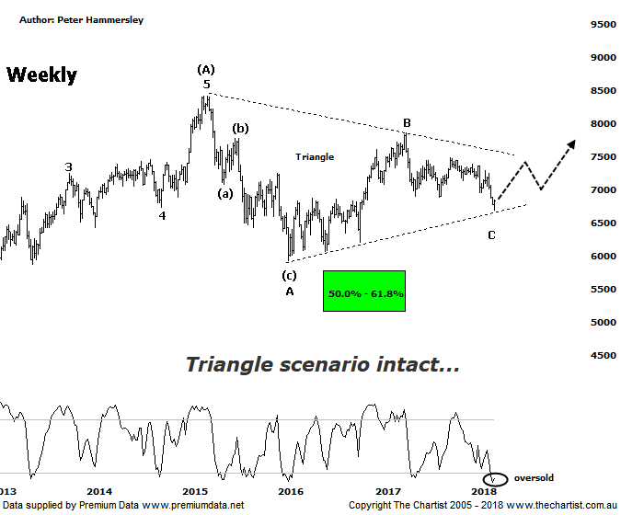

Bottom Line
5/4:
Daily Trend: Down
Weekly Trend: Down
Monthly Trend: Down
Support levels: 6699 / 6066 - 5934
Resistance levels: 7478 / 7859
Video Analysis
Watch Video Analysis Here
Technical Discussion
Although we have been anything but bullish on the banks over the past few months, our interest has been rekindled recently due to some potential bullish patterns forming. More on that below although it would be fair to say that from a fundamental perspective the sector is treading water as opposed to being outright bearish. Reportedly, funding costs have risen in recent weeks on the back of a spike in the bank bill-OIS spread. This is more significant to banks that are overweight in loan portfolios and mortgages that are priced off the cash rate. The consensus is that a 10 basis points increase reduces bank margins by between 1-2 basis points and earnings by around 1%. However, it seems likely that banks will offset this by raising mortgage rates meaning it shouldn’t be a major issue. Macquarie believes the banks are looking good value at current levels despite growth appearing to be less than robust. On the positive side of things, there is still the possibility of the big banks returning capital to shareholders via buybacks and special dividends. One thing we can’t forget though is the Royal commission into financial services which is now underway. This has been well documented before, so we won’t go into detail although it’s obviously been a major hurdle for the big four banks… and still is. Initial findings are due for release in September, but it’s expected that substantial penalties will have to be paid although this is likely already factored into price. Once initial results are announced perhaps the market will view the banks in a different light. Time will tell.
Reasons to be aligned to the Sector longer term (downside risk short to medium term):
→ APRA’s requirements should be met organically.
→ An enticing dividend yield should support prices.
→ Global and local regulation fears have eased.
→ A quarter of a century of economic growth suggests the economy is not about to implode.
→ Should credit conditions deteriorate further there is a real chance of central banks intervening.
→ The recent falls in interest rates can only be bullish for the market and the sector as a whole.
→ The Banking Sector has been the driving force behind broader market strength from 2009.
→ The longer-term trend is still up.
We’ve been concentrating on the weekly chart over recent times which shows a large symmetrical triangle as the headline pattern. Last time we were looking for short-term weakness to take price to the lower boundary, to be followed by a decent bounce. The first part of that equation has been adhered to with price over the past few days heading down to the lower trend line. The past couple of sessions have been much better and although it’s still very early stages in pattern progression, we are in a position to see a multi-week rally as a minimum. A push beneath the recent pivot low at 6699 would be a warning sign and increase the likelihood of the triangle invalidating. This wouldn’t be the end of the world although it would open the door for a much deeper retracement. In fact, the wave equality projection sits smack bang in the middle of the typical retracement zone of the whole leg higher off the 2009 lows between 5766 - 5140 which is still a hefty percentage fall from current levels. That said, the rotation down to those depths would present a very good buying opportunity although that’s something to consider much further down the track should the smaller degree patterns deteriorate. Although no bullish divergence is in place it’s worth noting that the banks are looking severely oversold at current levels. Our indicators are sitting in the oversold position on the daily, weekly and monthly charts. This doesn’t guarantee that a bounce is imminent although it increases the chances of a rally unfolding over the short-term. Much is going to depend on how US markets travel over the coming weeks, with volatility continuing to increase. The bottom line is, a bounce needs to kick into gear here if the triangle scenario is going to be the correction of choice.
Trading Strategy
Several of the big four banks are exhibiting similar patterns to the one shown here meaning technically we are in an area where a decent rally could unfold. However, if you are looking at the sector as a longer-term investment then you still need to wait for the upper boundary of the triangle to be overcome before initiating long positions. This means plenty of patience is going to be required as it’s still a hefty percentage gain to head back up to the potential breakout area. We’ll continue to monitor the banks and will put forward a recommendation when the patterns permit. A little more patience is required though.

