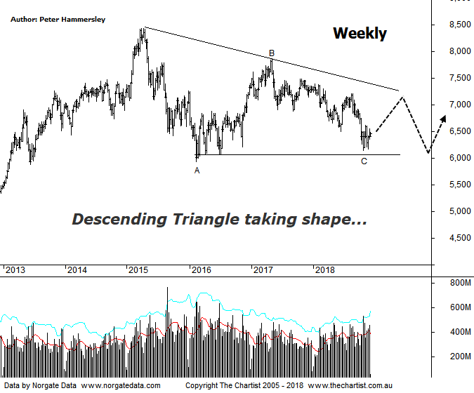

Bottom Line
3/12:
Daily Trend: Up
Weekly Trend: Down
Monthly Trend: Down
Support levels: 6066 - 5934
Resistance levels: 7478 / 7859
Video Analysis
Watch Video Analysis Here
Technical Discussion
It’s long overdue, but finally the banks have started to show some strength over the past few weeks. It’s still far too early in the bigger scheme of things to suggest something extremely bullish is in its very early stages although it’s undoubtedly a small step in the right direction. The Banking sector has risen around 6% since the 20th of November although strength kicked into gear at exactly the right time. We’ll come to the reasons why below though suffice to say, there wasn’t too much room for lower prices before thinking in terms of a much deeper retracement unfolding. Many analysts are still bearish the big four banks, citing the upcoming “housing crash” as a potential bearish trigger. Their words not mine! Although this would obviously hit the banks balance sheets it’s by no means a foregone conclusion that it’s going to occur. Thus far, the decline in house prices have been minimal, and it could be argued that it’s been controlled by regulators. In other words, there’s no reason to panic. The labor market is also holding up very well which reduces the chances of defaults which can only be positive. Let’s also not forget that the banks have already taken a big hit off the 2015 highs meaning plenty of the bad news surrounding the Royal commission etc. has been factored in. Plus, the attractive dividend yield must count for something.
Reasons to be aligned to the Sector longer term:
→ APRA’s requirements should be met organically.
→ An enticing dividend yield should support prices.
→ Global and local regulation fears have eased.
→ A quarter of a century of economic growth suggests the economy is not about to implode.
→ Should credit conditions deteriorate further there is a real chance of central banks intervening.
→ The recent falls in interest rates can only be bullish for the market and the sector as a whole.
→ The Banking Sector has been the driving force behind broader market strength from 2009.
→ The longer-term trend is still up.
Our reviews of the Banking sector have been few and far between over the past few months which solely comes down to the lack of clarity on the daily charts. As such, we’ll stick to the weekly chart this evening although this does show that the symmetrical triangle we’ve been watching has been invalidated, due to the lower boundary being overcome over the past few weeks. I’ve re-drawn the trend line which now shows a Descending triangle, with the lower boundary coming within a whisker of being tagged recently. However, the same guidelines apply in that ideally we need to see 5-internal swings within the pattern. I’ve pencilled in wave-C although it is feasible to get one final probe down to the lower boundary over the coming weeks should weakness kick in. More likely however that price is now going to climb up toward the upper trend line above 7000 which allows for a decent percentage gain from current levels. This would fit in nicely with the much talked about Santa rally even though we are looking at the weekly chart here. Should price head up to the upper trend line and reject, then the final probe down within wave-E should be in motion which is the prerequisite to the longer-term uptrend reigniting, albeit we are talking several months down the track as a minimum. The worst-case scenario is to head down through the lower trend of the triangle as this would open the door for a zigzag to unfold. This provides a target at 5373 which is where the wave equality projection sits. However, even if those lower levels are tagged we’ll still be looking for a buying opportunity. We don’t believe that Armageddon is upon us despite the negativity surrounding the sector.
Trading Strategy
Our bullish trigger for the pending trade in CBA wasn’t tagged so we continue to sit outside of the big four banks. That said, we have put swing trades forward in the written reviews although no formal recommendations have been forthcoming recently. This is likely to be the case for the foreseeable future. That said, if you are a more nimble trader there is plenty of scope for higher prices over the coming weeks if you want to be involved, especially as we expect price to head up to the upper boundary of the triangle in this instance.

