APA Group (APA)
Chart
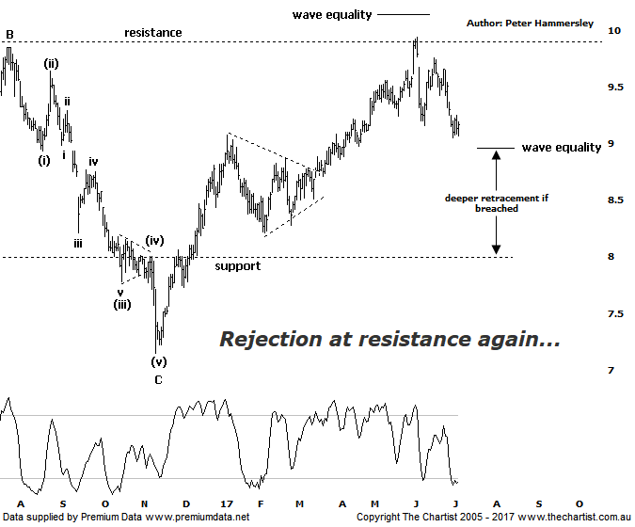
Bottom Line
6/7:
Daily Trend: Down
WeeklyTrend: Down
Monthly Trend: Up
Support Levels: $8.98 / $8.21 / $7.15
Resistance Levels: $9.94 - $10.14
Video Analysis
Watch Video Analysis Here
Technical Discussion
APA Group (APA) is involved in the natural gas infrastructure business. The Company operates through Energy Infrastructure, Asset Management and Energy Investments sections. Its Energy Infrastructure section includes gas transmission, gas compression, gas storage assets and Emu Downs Wind Farm. Its Asset Management section provides commercial, operating services and asset maintenance services to the Company's energy investments and to a range of third-parties. The Company operates in Australia only. It holds various minority interests in energy infrastructure enterprises. The Energy Infrastructure assets are managed as the East Coast Grid plus Northern Territory (Queensland, New South Wales, Victoria, South Australia and the Northern Territory) and Western Australia. For the six months ending the 31st of December 2016 revenues increased 12% to A$1.17B. Net income increased 40% to A$139.8M. Revenues highlight the Energy infrastructure section increase of 23% to A$928.3M. Broker consensus is currently “Sell”. The dividend yield is 4.5%.
Reasons to be cautious longer term:
→ An environment of rising interest rates will be challenging.
→ High gas prices and the lack of supply response limits opportunities.
→ Confidence remains muted due to regulatory uncertainty.
→ Council of Australian Government meeting in December could have negative implications.
→ ACCC findings advocate lowering the threshold for full regulation of APA’s pipelines.
→ Lacklustre price action taking hold from March 2015.
We continue to believe APA is in a strong position to resume the trend which terminated back in May 2015 although whether a little more time is required remains to be seen. From those highs made just over a couple of years ago price has been consolidating which we are still viewing as being a healthy attribute. The problem now is that the leg higher from the November 2016 lows can still be counted as a 3-wave movement. This will be the case unless the wave equality projection sitting up at $10.14 is overcome with a push above likely triggering a multi-month trend higher which is something we’d want to be part of. For now though, a retracement is unfolding and we need to keep a close eye on the wave equality projection sitting at $8.98 as a push beneath that level would suggest a deeper retracement is going to unfold. This would be deemed the worst-case scenario as it would open the door to head all the way back down toward the prior pivot lows made late last year circa $7.15 which is a decent retracement from current levels. In other words, an inflection point has been reached although we have our aforementioned bullish and bearish triggers in place which is all we can do. Whether the deeper retracement materialises or not, there’s plenty to like longer-term. That said, brokers continue to dislike the stock almost without exception.
Trading Strategy
As stated last time, we don’t advocate initiating positions with overhead resistance just above which is still the case here. Also, we need to keep a close eye on the wave equality projection as a push beneath would open the door to see an impulsive movement down toward the low of wave-C just above $7.00. However, signs of strength at those lower levels would present a very good buying opportunity, obviously several months down the track. For now, we’ll continue to stand aside until the smaller degree patterns regain clarity.

