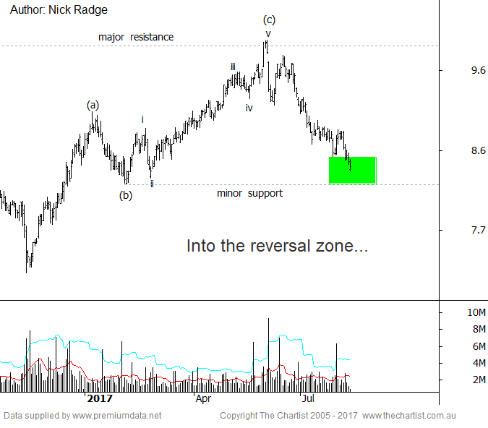

Bottom Line
11/8:
Daily Trend: Down
WeeklyTrend: Down
Monthly Trend: Neutral
Support Levels: $8.21 / $8.21 / $7.15
Resistance Levels: $8.86 / $9.94 - $10.14
Video Analysis
Watch Video Analysis Here
Technical Discussion
As Australia's leading energy infrastructure company, APA owns and manages a $20bn portfolio of assets, including a 15,000km natural gas pipeline network across mainland Australia. The company also has interests in energy infrastructure investments, gas processing plants, several unlisted energy infrastructure businesses in South Australia and South East Queensland and a partnership is the SEA Gas Pipeline that transports natural gas from the Otway Basin to Victoria and South Australia. The company has a 2017 forecast dividend of 5.2% and has a slight negative sentiment from analysts.
Reasons to be cautious longer term:
→ A rising interest rate environment will be challenging.
→ High gas prices and the lack of supply response limits opportunities.
→ Recently tightened its guidance ahead of FY17 results
→ Regulatory restrictions continue
→ Company continues to face gas pipeline re-pricing pressure on existing contracts.
The continued slide through the $9.08 - $9.16 zone of support has placed the stock in a longer term precarious state; not necessarily overly bearish, but certainly not bullish. By all intents that bullish argument, in the short to medium term, can now be dismissed and indeed we'd expect to see an extended sideways period of trading, not dissimilar to what has been in place since early 2015. If prices continue to track in the range then it's from about this zone where a bounce could unfold. The green box shown in todays chart is the typical 50.0% to 61.8% retracement zone of the October 2016 - June 2017 leg higher. The lower side also coincides with a moderate level of support. Should prices hold here then a near term bounce is likely although it should be followed by ongoing weakness which should see the lower end of the range come into play later this year. If commodity cycle has entered a cyclical bearish phase, which we believe they have, and if interest rates rise, which remains questionable, then downside pressure will remain.
Trading Strategy
As prices are in the middle of the larger range we don't see any prudent trade, especially when headwinds remain on an individual company level and on a broader market level. If some type of a-b-c bounce off this zone takes shape, and assuming it occurs on low volume, then a short side trade could be initiated looking for a swing down toward $7.60 - $7.70. Traders should stand aside for now and longer term investors are encouraged to await better buying levels.

