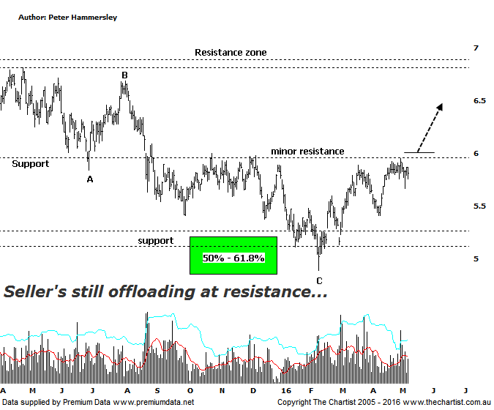

Bottom Line
10/5:
Daily Trend: Neutral
Weekly Trend: Up
Monthly Trend: Up
Support Levels: $4.89 / $4.11
Resistance Levels: $6.00 / $6.69 / $6.97
Video Analysis
Watch Video Analysis Here
Technical Discussion
AMP Limited (AMP) is a financial services and wealth management company operating across financial planning, insurance, asset management and retail banking. It has a significant network of 4300 advisors across Australia and New Zealand, as well as relationships with independent financial planning groups. Its asset management business is extensive with large and diversified portfolios across all major asset classes. For the year ending the 31st of December 2015 revenues decreased 18% to A$13.98B. Net income increased 10% to A$972M. Revenues reflect the dividend income - Investment decrease of 12% to A$6.15B. Broker / Analyst consensus is currently “Buy”. The dividend yield is 4.8%.
Reasons to remain bullish longer term (caution short term):
→ Reforms recently announced by the government should be beneficial.
→ Improved operating momentum across wealth management continues.
→ Robust flows offer both growth potential and a respectable dividend.
→ On a sector basis there are signs that Life Insurance may have bottomed out.
→ A recovery is being seen in the life business.
→ Stake in China Life Pension increases exposure to fast growing Asian economies.

We have to go all the way back to early March to find our last review of AMP although with price continuing to struggle to gain any sort of traction there hasn’t been any agency to take another look. Price is still struggling to get up through the minor line of resistance although at least it is now posturing in the right place due to the impulsive movement higher that commenced in mid-April. If price is to break higher, we’ll need to see increasing volume start to reappear otherwise any strength is going to be short-lived. The line in the sand is the prior pivot high sitting at $6.00 which came within a whisker of being tagged last week. A push up through that aforementioned level coupled with a high close would set the stage for a continuation up toward the next zone of resistance just beneath $7.00 which is still a reasonable percentage gain from current levels. It is very difficult to get overly bullish longer term which is solely due to the trading range that’s been taking hold since 2009, albeit it’s a fairly large trading range between $3.50 - $7.00. Fundamentally, there are headwinds for investors which come in the form of claims issues and possible modifications to superannuation tax. That said, this is likely already factored into price so I’m not overly concerned in regard to this potential risk. Whichever way you look at it though, price continues to be stagnant which is a trait that needs to change.
Trading Strategy
If you’re a more nimble trader, then the strategy is to buy following a push above $6.00. Alternatively wait until price closes above that level if you want a little more confirmation. Just be aware that we are still seeing plenty of fakeout patterns currently meaning losing a few cents isn’t a big deal, especially when it reduces the chances of price breaking out and then immediately reversing down again. There is no formal recommendation today although this is only due to the amount of long trades that we currently hold. If you want to be involved here, place the initial stop just beneath the prior pivot low which at this stage is last Friday’s low at $5.66. Take profits at the next zone of resistance just beneath $7.00, or at least tighten the trailing stop significantly as those higher levels are approached.

Disclosure: Nick Radge holds.

