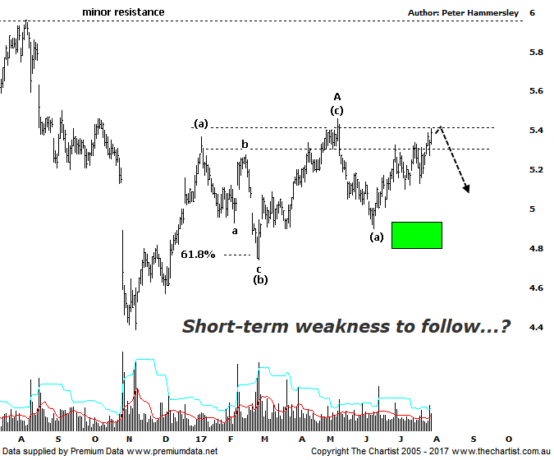

Bottom Line
31/7:
Daily Trend: Up
Weekly Trend: Up
Monthly Trend: Up
Support Levels: $4.93 / $4.74 / $4.38
Resistance Levels: $5.46- $5.72 / $6.00
Video Analysis
Watch Video Analysis Here
Technical Discussion
AMP Limited (AMP) is a financial services and wealth management company operating across financial planning, insurance, asset management and retail banking. It has a significant network of 4300 advisors across Australia and New Zealand, as well as relationships with independent financial planning groups. Its asset management business is extensive with large and diversified portfolios across all major asset classes. For the year ending the 31st of December 2016 revenues increased 6% to A$14.77B. Net loss was A$344M against income of A$972M. Revenues highlight the Wealth Management(WM) section increase of 7% to A$1.5B, the AMP Capital section increase of 20% to A$387M and the AMP Bank section increase of 11% to A$311M. Broker / Analyst consensus is currently “Sell”. The dividend yield is 5.2%.
Reasons to remain bullish longer term (caution short term):
→ Growing Chinese investment in funds management.
→ Management hoping to double bank profits over the next five years by leveraging its adviser network.
→ Recently announced a $500m buy-back.
→ Transitioning to a higher growth and less capital intensive business.
→ Continues to de-risk the life business.
→ Reforms recently announced by the government should be beneficial.
→ Improved operating momentum across wealth management continues.
Lacklustre is probably a word that can best describe the price action of AMP recently, albeit some strength hasn’t materialised over the past few weeks. However, it hasn’t been an impulsive leg higher which suggests there is likely another leg down to come before seeing a more sustainable trend north. Last time we also noted the potency of the leg down from the high of wave-(c) made back in early May. This looks too sharp to complete the whole corrective pattern. In other words, nothing changes in that clear rejection in the current zone of resistance would likely result in a continuation back down toward $5.00 to complete a larger 3-wave countertrend move into wave-B. It’s from those lows that we’ll be looking for another multi-month trend higher, likely taking price back up toward the next line of resistance circa $6.00 although this is a target to consider much further down the track, assuming the patterns unfold in textbook form. It would take an immediate push up through the high of wave-A at $5.46 in a move that sticks before thinking in terms of avoiding the anticipated one final probe down. One headwind for the moment is Type-A bearish divergence with price making a higher high whilst our oscillator has only made a lower high. It’s yet to trigger, but if it does it will mean an interim top is likely in place which should not be overcome until our oscillator unwinds back into the oversold position. The stepping process higher from early July means we can only retain a neutral stance, with little to get too excited about at this stage.
Trading Strategy
Although there’s a good chance of seeing another leg South there is not enough in it to warrant a formal recommendation. However, clear rejection over the coming week or two would provide an opportunity if you are that way inclined. Look to take profits around $5.00 or at least tighten the trailing stop significantly as those lower levels are approached. We’ll stand aside and look for a buying opportunity at those aforementioned lower levels although it’s going to take several weeks for the larger correction to complete.

Disclosure: Nick Radge holds.

