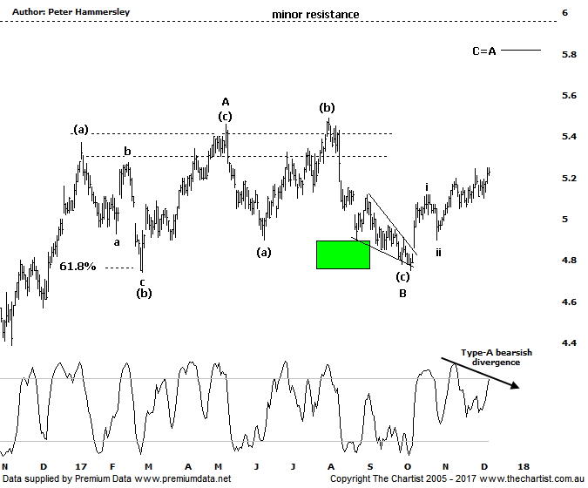

Bottom Line
8/12:
Daily Trend: Up
Weekly Trend: Up
Monthly Trend: Up
Support Levels: $4.79 - $4.74 / $4.38
Resistance Levels: $5.46- $5.72 / $6.00
Video Analysis
Watch Video Analysis Here
Technical Discussion
AMP Limited (AMP) is a financial services and wealth management company operating across financial planning, insurance, asset management and retail banking. It has a significant network of 4300 advisors across Australia and New Zealand, as well as relationships with independent financial planning groups. Its asset management business is extensive with large and diversified portfolios across all major asset classes. For the six months ending the 30th of June 2017 revenues increased 25% to A$7.6B. Net income decreased 15% to A$445M. Revenues highlight the AMP capital section increase of 9% to A$228M, bank section increases of 12% to A$172M and the wealth management(WM) section increase of 1% to A$736M. Broker / Analyst consensus is currently “Hold”. The dividend yield is 5.4%.
Reasons to remain bullish longer term (caution short term):
→ Looking to acquire revenue streams in advice to offset margin pressure in the Australian wealth management business.
→ AMP capital benefited from Asian demand and interest in real estate and infrastructure.
→ A new re-insurance arrangement for the life book should raise $500m.
→ Growing Chinese investment in funds management.
→ Management hoping to double bank profits over the next five years by leveraging its adviser network.
→ Transitioning to a higher growth and less capital intensive business.
→ Continues to de-risk the life business.
→ Reforms recently announced by the government should be beneficial.
→ Improved operating momentum across wealth management continues.
There was everything to like about the patterns during our last look at AMP with a falling wedge, also known as Ending Diagonal Triangles completing the correction into wave-B. From that juncture we’ve already seen an impulsive leg higher to wave-i followed by the correction into wave-ii which sets the stage for continued strength. Although higher prices have been made, there hasn’t been a lot of conviction behind the move. Within stocks, wave-iii is usually the strongest of all the impulsive waves and although it kicked off on the right track momentum has waned over the past few weeks. The culprit is once again bearish divergence with price making a higher high whilst our oscillator has failed to confirm by making a lower high. The saving grace is that it’s yet to trigger although two or three days of weakness will likely do exactly that. This wouldn’t guarantee a leg lower, but it usually means that the prior pivot high will not be overcome until our oscillator rotates all the way down into the oversold position - or invalidates. With the smaller degree wave count starting to deviate from textbook this would obviously be less than ideal. The bottom line is that buyers need to step up pretty much immediately, driving price up through $5.27 with some conviction. That’s where the wave equality projection sits which is always an important juncture. Until that level is overcome it’s possible that a corrective pattern higher is unfolding although as can be seen, we are running with the more bullish wave count still. If some traction can be gleaned price should head up to the wave equality projection of the larger pattern just above $5.80, and even up toward the minor line of resistance just beneath $6.00. For now though, it’s important that the next significant move is to the upside otherwise the patterns will start to take a turn for the worse.
Trading Strategy
We continue to hold our long position from $4.97 but although price is heading in the right direction it’s still too early to move the protective stop to breakeven. However, it has been moved to $4.89 to reduce the risk, with the worst-case scenario being to make a very small loss. Obviously, this is something we don’t want to transpire although we still have room to move during normal market noise without getting stopped out prematurely. If you aren’t already involved it’s best to stand aside.

Disclosure: Nick Radge holds.

