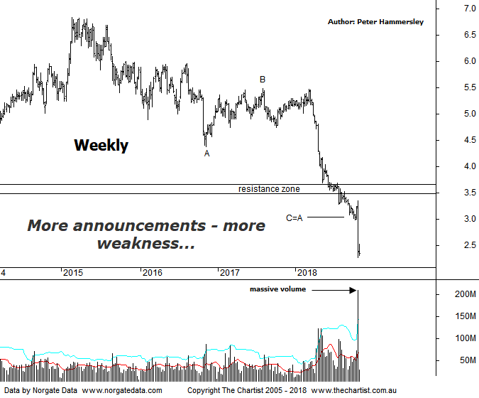

Bottom Line
29/10:
Daily Trend: Down
Weekly Trend: Down
Monthly Trend: Down
Support Levels: N/A
Resistance Levels: $3.50 - $3.69 / $4.39 / $5.49
Video Analysis
Watch Video Analysis Here
Technical Discussion
AMP Limited (AMP) is a financial services and wealth management company operating across financial planning, insurance, asset management and retail banking. It has a significant network of 4300 advisors across Australia and New Zealand, as well as relationships with independent financial planning groups. Its asset management business is extensive with large and diversified portfolios across all major asset classes. For the six months ending the 30th of June 2018 revenues decreased 6% to A$7.15B. Net income decreased 74% to A$115M. Revenues highlight the Australian Wealth Protection(WP) section decrease of 98% to A$1M, the Wealth Management(WM) section decrease of 3% to A$716M and the New Zealand Financial Services section decrease of 14% to A$56M. Broker / Analyst consensus is currently “Sell”. The dividend yield is 12.2%.
Reasons to be cautious:
→ The fallout from the Royal commission still an unknown.
→ Increased possibility of a buyback following results.
→ A strategic review may be a potential bullish catalyst.
→ Growing Chinese investment in funds management.
→ Management hoping to double bank profits over the next five years by leveraging its adviser network.
→ Transitioning to a higher growth and less capital intensive business.
→ Continues to de-risk the life business.
→ Reforms recently announced by the government should be beneficial.
→ Improved operating momentum across wealth management continues.
We were looking for a bounce up toward the new zone of resistance following our last review but although a rally ensued it was short-lived, with our target coming just short of being tagged. Yet again it’s been a case of negative announcements triggering further panic. This time around it was the combination of a Q3 cash flow update, a portfolio review and various sales that caused holders to offload. The company has not only broken through multi-year support, it’s also headed down through the all-time lows made back in 2003. In other words, there’s no support left to focus on which is not a good sign. As a minimum price would need to get back up toward $3.75 to suggest a low is locked in and although it doesn’t look too far above current levels on this weekly chart it’s a substantial percentage gain to get anywhere near those heights. Sellers are in total control and until signs of accumulation start to appear the risk remains to the downside, irrespective of the significantly oversold levels of the stock. From an Elliott stance the wave equality projection has been overcome which is never a good sign. The further price gets down through that target, the greater the chance that a more bearish 5-wave move lower is going to unfold which is now realistic here. The big clue will be in how any bounce unfolds and whether it’s impulsive or corrective in nature. What we can say is that over the past three years or so the impulsive price action has been to the downside which is not a good trait.
Trading Strategy
If you are still a fan of this company it may be wise to look elsewhere for buying opportunities as it could be a substantial amount of time before we can become confident that a major low is locked in. As mentioned above, it would take an impulsive move up through the zone of resistance before even thinking in terms of something more bullish unfolding medium to longer-term. In fact, a corrective move back up toward $3.50 would present a shorting opportunity although even a rally of that magnitude is looking a little out of reach at this juncture. Either way, we’ll continue to sit this one out.

