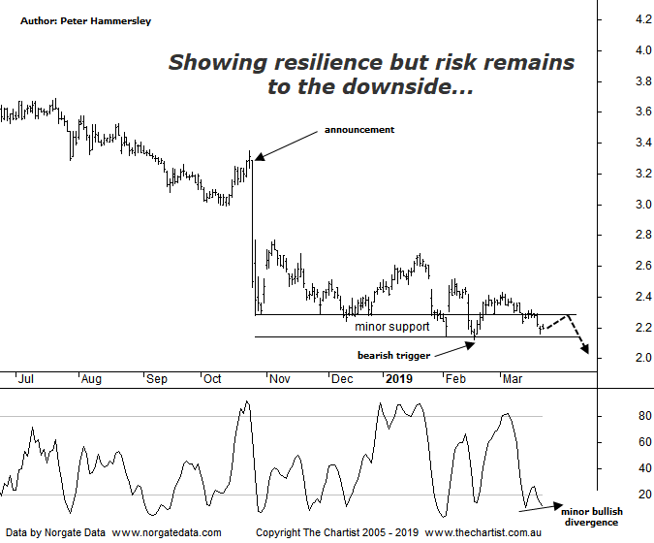

Bottom Line
22/3:
Daily Trend: Down
Weekly Trend: Down
Monthly Trend: Down
Support Levels: $2.12
Resistance Levels: $2.43 - $2.77 / $3.50 - $3.69
Video Analysis
Watch Video Analysis Here
Technical Discussion
AMP Limited (AMP) is a financial services and wealth management company operating across financial planning, insurance, asset management and retail banking. It has a significant network of 4300 advisors across Australia and New Zealand, as well as relationships with independent financial planning groups. Its asset management business is extensive with large and diversified portfolios across all major asset classes. Full-year profit declined by 97% to $28 million which was beneath most forecasts. Not surprisingly the dividend has been slashed. The Royal commission findings have damaged the company’s reputation. Broker / Analyst consensus is currently “Hold”. The dividend yield is 6.4%.
Reasons to be cautious:
→ It could look a bargain once it returns surplus capital although this could take years to unfold.
→ The “protecting your super package bill” is going to adversely affect earnings.
→ Royal commission findings triggered a one-off spike only.
→ The risk of regulatory action remains.
→ Recent results not taken well by the market.
→ Earnings affected by an increase in the cost base.
→ Earnings risk remains to the downside.
→ No obvious catalyst for an improvement in business.
→ Continues to de-risk the life business.
→ The technical picture continues to deteriorate.
Brokers appear happy to sit on the fence, with most holding a “neutral” stance. Reading deeper into their findings shows that the main theme is uncertainty, plus it’s difficult to find a compelling reason to take a more bullish stance. This is one of the reasons why we like to concentrate on the technical picture as it usually tells a story. Last time we noted that price had broken down through a line of resistance although a few buyers have stepped up over the past few weeks meaning it now becomes a zone of support. Not that I’m suggesting a strong leg higher is about to kick into gear although it is providing a brief reprieve. The bottom line is, the bad news continues to flow which isn’t doing anything for investor sentiment. What we can say is that when everybody and their dog are bearish (sentiment at extreme levels) it’s usually time to be looking for a significant low. There’s no doubting the fact that sentiment is low although it likely needs to deteriorate further. On the weekly chart (not shown) some bullish divergence has triggered which has no doubt been the reason for the recent show of resilience. It should take several weeks for our indicator to unwind fully meaning downside should be limited until this transpires. I reiterate that at this stage the best we can hope for is a bounce or even a sideways consolidation before the next leg South kicks in. There is now a significant multi-year zone of resistance running from $3.50 which is a level that would need to be overcome before even thinking in terms of a bottom being in place. A bounce of that magnitude simply doesn’t look likely at this stage.
Trading Strategy
If there was no bullish divergence in place there would have been a case for short-selling following a break beneath the lower boundary of the line of support at $2.12. However, this is going to be a headwind for those looking for a shorting opportunity meaning the best course of action is to remain sidelined. A sideways move with a bias to the upside will allow our indicator to head into the overbought position on the weekly chart although as already mentioned, this is going to take several weeks.

