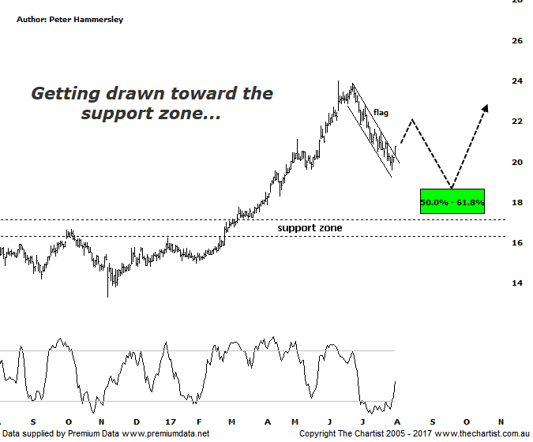

Bottom Line
2/8:
DailyTrend: Neutral
WeeklyTrend: Down
Monthly Trend: Up
Support levels: $18.65 - $17.39 / $16.68 - $16.19
Resistance Levels: $23.98
Video Analysis
Watch Video Analysis Here
Technical Discussion
Aristocrat Leisure (ALL) provides gaming solutions. The Company's main activities include design, development and distribution of gaming content, platforms and systems. The Company's sections include The Americas, Australia and New Zealand, Digital, and International Class III. The Company offers a range of products and services, including electronic gaming machines and casino management systems. The Company also operates within the online social gaming and real money wager markets. Through Video Gaming Technologies, Inc. (VGT), it develops, manufactures and distributes casino games for the Class II and emerging markets. It offers Oasis 360, which is a casino management system and contains a portfolio of open-platform technologies. It also offers System 7000 casino management system. For the six months ending the 31st of March 2017 revenues increased 21% to A$1.23B. Net income increased 57% to A$249.6M. Revenues reflect the America section increase of 18% to A$715.8M and the International Class III section increase from A$60.7M to A$129.2M. Broker consensus is “buy”. The dividend yield is 1.2%.
Reasons to remain bullish (downside feasible short-term)
→ Lightning links has underpinned FY17 earnings with Dragon link looking positive into FY18.
→ Strong market share growth.
→ Plenty of products in the pipeline to drive growth until 2022.
→ Improvement in the US economy likely to drive earnings.
→ Exceptional trend behind it although the current retracement should have further to travel.
This is our first review of ALL for many years although we are going to delve straight into the daily timeframe rather than starting with the bigger picture. In fact, even the weekly chart only shows strong impulsive price action which has been materialising since 2011. Back then price was sitting at a lowly $1.88 which just emphasises the potency of the trend that’s been unfolding over the past few years. There have been healthy pauses along the way although the retracement over the past few weeks has been the most significant pull-back since those 2011 lows. The most important aspect of this daily chart is the impulsive nature of the decline that commenced in mid-June this year. This suggests a larger corrective pattern lower is unfolding. Not that we are expecting something more sinister to the downside although a rotation down into the typical retracement zone as annotated is more than feasible over the coming weeks. That lower target shows good confluence with the zone of support making it an area to watch closely. The prerequisite to higher prices is that a corrective pattern lower unfolds which means a bounce needs to unfold pretty much immediately. This would then be followed by one final probe down into the target zone. Buyers returning just above $16.00 would suggest the strong prior uptrend is about to reignite. It would take a push beneath the lower boundary of the zone of support before thinking in terms of a much deeper and more significant retracement unfolding.
Trading Strategy
If you are holding this stock it may be wise to place the protective stop just beneath the zone of support at $16.00 as a retracement down into that area is looking likely. Alternatively, take profits and look to re-enter at those lower levels following signs of strength. If you want to be involved in an exceptionally strong trending stock then some patience is required as it could be a couple of months before the next big buying opportunity presents itself. Definitely one for the watchlist though.

