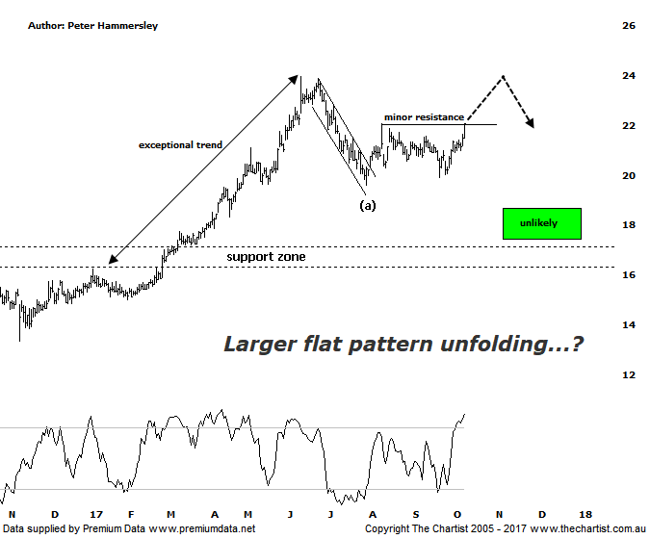

Bottom Line
10/10:
DailyTrend: Up
WeeklyTrend: Up
Monthly Trend: Up
Support levels: $19.92 - $19.61 / $18.65 - $17.39
Resistance Levels: $23.98
Video Analysis
Watch Video Analysis Here
Technical Discussion
Aristocrat Leisure (ALL) provides gaming solutions. The Company's main activities include design, development and distribution of gaming content, platforms and systems. The Company's sections include The Americas, Australia and New Zealand, Digital, and International Class III. The Company offers a range of products and services, including electronic gaming machines and casino management systems. The Company also operates within the online social gaming and real money wager markets. Through Video Gaming Technologies, Inc. (VGT), it develops, manufactures and distributes casino games for the Class II and emerging markets. It offers Oasis 360, which is a casino management system and contains a portfolio of open-platform technologies. It also offers System 7000 casino management system. For the six months ending the 31st of March 2017 revenues increased 21% to A$1.23B. Net income increased 57% to A$249.6M. Revenues reflect the America section increase of 18% to A$715.8M and the International Class III section increase from A$60.7M to A$129.2M. Broker consensus is “buy”. The dividend yield is 1.2%.
Reasons to remain bullish:
→ Growth in high-quality recurring earnings.
→ Significantly improve cash flow.
→ Share in the North American gaming operations.
→ Diversification due to the acquisition of Plarium.
→ Lightning links has underpinned FY17 earnings with Dragon link looking positive into FY18.
→ Plenty of products in the pipeline to drive growth until 2022.
→ Improvement in the US economy likely to drive earnings.
→ Exceptional trend behind it although the current retracement should have further to travel.
Aristocrat Leisure is an exceptionally strong trending stock which is what drew us to the company a couple of months ago when we initiated coverage. However, a decent retracement was witnessed in late June this year which was the first of its kind for a significant period of time. This isn’t major reason for concern although during our last review the door was open to head down to the typical retracement zone either side of $18.00. Although this is still feasible, the rally over the past couple of weeks or so is now suggesting a shallower corrective pattern is likely going to be the way forward. Not that we are looking for all-time highs to be overcome at the first attempt though it’s more than feasible to test those higher levels circa $24.00 before another bout of weakness takes hold. Price is currently hovering around a minor line of resistance with a close above todays high providing confirmation that price will likely continue up toward those June highs. Rejection at those higher levels would likely result in a flat pattern unfolding which will take price back down toward the recent pivot low at $19.61. That’s looking way into the future, so first of all let’s see if the minor line of resistance can be overcome in a move that sticks as this would suggest a multi-week trend is underway. We noted in our review of MQG yesterday that trying to project high probability reversal points in exceptionally strong trending stocks is a difficult feat - and trends don’t come much stronger this. As such, we’ll have to reassess the patterns on a regular basis as a sudden resumption to strong impulsive price action will result in us reviewing the patterns. For now though, short-term strength is likely to be followed by a multi-week leg lower.
Trading Strategy
If you’re a short-term trader you could initiate long positions following a close above todays high at $22.08 with the initial stop placed beneath Fridays low at $20.97. Look to take profits up around all-time highs just beneath $24.00 or at least tighten the trailing stop at those higher levels if you want to allow the trade room to run. If you are a longer-term trader or investor waiting for the bigger buying opportunity then more patience is required.

