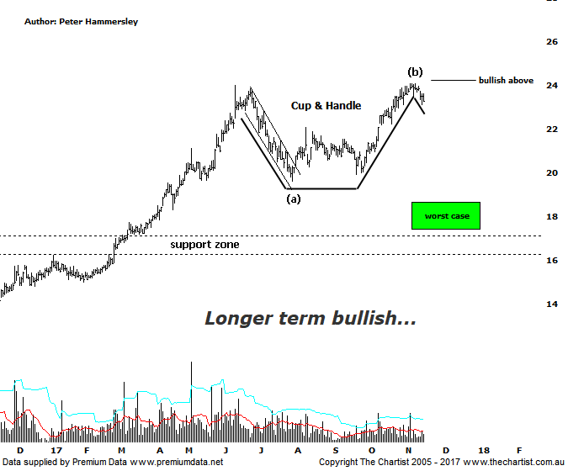

Bottom Line
16/11:
DailyTrend: Down
WeeklyTrend: Up
Monthly Trend: Up
Support levels: $19.92 - $19.61 / $18.65 - $17.39
Resistance Levels: $24.09
Video Analysis
Watch Video Analysis Here
Technical Discussion
Aristocrat Leisure (ALL) provides gaming solutions. The Company's main activities include design, development and distribution of gaming content, platforms and systems. The Company's sections include The Americas, Australia and New Zealand, Digital, and International Class III. The Company offers a range of products and services, including electronic gaming machines and casino management systems. The Company also operates within the online social gaming and real money wager markets. Through Video Gaming Technologies, Inc. (VGT), it develops, manufactures and distributes casino games for the Class II and emerging markets. It offers Oasis 360, which is a casino management system and contains a portfolio of open-platform technologies. It also offers System 7000 casino management system. For the six months ending the 31st of March 2017 revenues increased 21% to A$1.23B. Net income increased 57% to A$249.6M. Revenues reflect the America section increase of 18% to A$715.8M and the International Class III section increase from A$60.7M to A$129.2M. Broker consensus is “buy”. The dividend yield is 1.1%.
Reasons to remain bullish:
→ Growth in high-quality recurring earnings.
→ Significantly improve cash flow.
→ Share in the North American gaming operations.
→ Diversification due to the acquisition of Plarium.
→ Lightning links has underpinned FY17 earnings with Dragon link looking positive into FY18.
→ Plenty of products in the pipeline to drive growth until 2022.
→ Improvement in the US economy likely to drive earnings.
→ Exceptional trend behind it although the current retracement should have further to travel.
Price was taking on a minor line of resistance last month with an upside break being the ideal situation. This transpired the very next day from where a decent trend has unfolded. However, we were looking for a rotation up toward all-time highs around $23.98 which is an area that has been achieved. The prior pivot high also coincided with bearish divergence on this daily chart so it doesn’t come as any great surprise that a short retracement has unfolded over the past week or so. The recent high is unlikely to be overcome until our oscillator heads all the way back down into the oversold position which is going to take several days as a minimum. From an Elliott stance we’d still like to get one final probe down toward the low of wave-(a) circa $20.00 although this is by no means a foregone conclusion. It’s an exceptionally strong trending stock so we must be open to the possibility that buyers are going to be waiting in the wings to get a good entry point into a strong company. The larger degree patterns don’t lend themselves to a high probability wave count and as such we’ll stick with the more recent price action. Should wave-(b) be in place, then a leg very similar to that of wave-(a) should start to unfold. If the all-time high previously mentioned is overcome, then we are likely incorrect with our labelling. From a more conventional pattern perspective the recent Double Top also locked in a Cup & Handle which is a pattern that’s been cropping up quite often over recent times. The current retracement could be the handle which ideally will terminate when the bearish divergence unwinds. In other words, even if our wave count is incorrect there will still be an opportunity to jump on if the patterns take a turn for the better.
Trading Strategy
“…If you’re a short-term trader you could initiate long positions following a close above today’s high at $22.08 with the initial stop placed beneath Fridays low at $20.97. Look to take profits up around all-time highs just beneath $24.00…” If you initiated positions and are still holding it may be wise to take profits, especially with the bearish divergence still having an influence. If the Cup & Handle proves to be the pattern of choice, there will be an opportunity to jump back on. We are keen to put forward a formal recommendation shortly although the timing isn’t right quite yet.

