ASX-200 Materials Sector (XMJ)
Chart
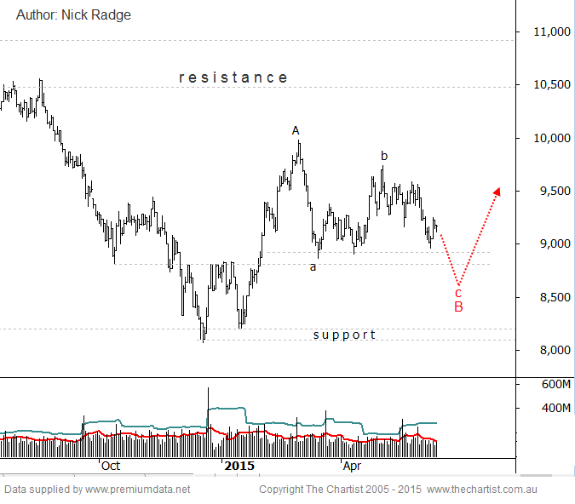
Bottom Line
15 Jun:
Daily Trend: Neutral
Weekly Trend: Neutral
Monthly Trend: Down
Support levels: 8871 / 8804 / 8075 / 6423
Resistance levels: 9640 / 9983 /10554
Video Analysis
Watch Video Analysis Here
Technical Discussion
Price action remains corrective with downside risks still high on the agenda. A retest of the minor support zone just below 9000 would complete the ideal washout and may well set the foundation for renewed strength back to the early 2014 highs.
Reasons to be cautious:
→ Investors continue to seek safety within companies offering sustainable dividends.
→ Struggling to make headway even though the US economy is growing, suggestive concerns remain in place with China.
→ Small resource stocks have come under pressure again having previously reversed from strong downtrends.
→ Technically the patterns are at a significant level both in terms of price and time.
The Materials sector can't seem to catch a decent break at the moment, although medium term price action looks positive from a technical standpoint. The big players have a few issues to deal with which is adding weight on the sector. The RIO on-market buy back in the UK is struggling to gain traction whereas the Australian off-market buy back has been scaled up. BHP on the other hand has been given mixed blessing by the analysts, some of who are concerned about the ability to support its dividend commitment, indeed to even grow its dividends. That coupled with the potetntial need to increase M&A activity to offset a decline in expected Oil growth, has made some analysts downgrade the stock in the short term. Technically we do see scope for a more complex pattern which may lead to a dip back to 8700 and complete a symmetrical a-b-c pattern. Such a move would also complete the larger degree wave-B. If buyers enter there, or if the decline is on low volume, then it could offer swing traders a solid opportunity to catch a ride back toward 10,500. The index has the ability to get going when sentiment is working for it, as was evidenced earlier this year, but for now, the broader market sentiment is poor and until that corrects we need to expect more meandering with a downside bias. Any break of the major support at 8,100 is cause for concern.
Trading Strategy
In this environment we really only want to trade picture perfect type patterns. In this case that would mean further weakness to achieve wave-c equality with wave-a down at 8600. That would give us the ideal upside potential with a well defined stop loss level, or a few levels should we choose. Until then we risk being caught up in a lot more chop. Patience required here.

