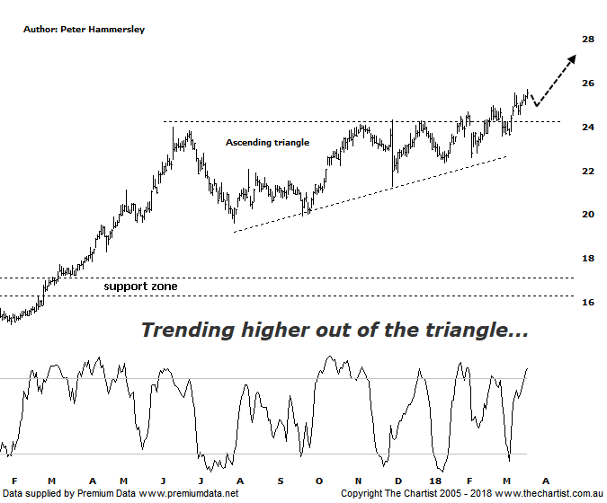

Bottom Line
21/3:
DailyTrend: Up
WeeklyTrend: Up
Monthly Trend: Up
Support levels: $24.32 - $23.98 / $19.92 - $19.61 / $18.65 - $17.39
Resistance Levels: N/A
Video Analysis
Watch Video Analysis Here
Technical Discussion
Aristocrat Leisure (ALL) provides gaming solutions. The Company's main activities include design, development and distribution of gaming content, platforms and systems. The Company's sections include The Americas, Australia and New Zealand, Digital, and International Class III. The Company offers a range of products and services, including electronic gaming machines and casino management systems. The Company also operates within the online social gaming and real money wager markets. Through Video Gaming Technologies, Inc. (VGT), it develops, manufactures and distributes casino games for the Class II and emerging markets. It offers Oasis 360, which is a casino management system and contains a portfolio of open-platform technologies. It also offers System 7000 casino management system. For FY17 underlying net profit was up 36.5% to $543m. The company continues to envisage continued growth in FY18. Broker consensus is “buy”. The dividend yield is 1.3%.
Reasons to remain bullish:
→ The proposed acquisition of Big Fish viewed as being positive by brokers.
→ Growth in high-quality recurring earnings.
→ Significantly improve cash flow.
→ Share in the North American gaming operations.
→ Diversification due to the acquisition of Plarium.
→ Lightning links has underpinned FY17 earnings with Dragon link looking positive into FY18.
→ Plenty of products in the pipeline to drive growth until 2022.
→ Improvement in the US economy likely to drive earnings.
→ Exceptional trend behind it.
We have been keeping an eye on ALL over the past few weeks which has resulted in regular reviews. The reason being, price has broken higher out of a large ascending triangle which also coincides with all-time highs being overcome. The reason we’ve refrained from making a recommendation recently comes on the back of bearish divergence on the weekly chart (not shown) which is always reason to be cautious. This is still a headwind on the larger timeframe although it’s no longer a textbook example and is within touching distance of invalidating. Price has continued to head higher meaning our oscillator has done the same. Should this trait continue over next few days then the divergence will no longer be a major stumbling block which would be a very positive turn of events for the patterns. On this daily timeframe we’ll continue to focus on the ascending triangle which still keeps the door open for higher prices over the coming months. If we measure the depth of the triangle and project it from the breakout it provides a target up around $30.00 which is nothing to be sneezed at from current levels. However, when considering there is plenty of blue sky territory ahead there’s no reason why that aforementioned level can’t be overcome by a substantial margin. From a more conventional pattern perspective the sideways consolidation that’s been unfolding since June of last year can only be viewed in a positive light, especially when looking at the potency of the prior trend higher over the years. Every trend needs to take a pause for breath and it could well be that ALL has completed exactly that. Brokers and analysts have started to suggest the company is fully valued which has no doubt caused a few investors to take some profits. However, the patterns continue to prove themselves which is much more significant to us.
Trading Strategy
We are not quite there yet regarding putting forward a formal recommendation although the time is undoubtedly getting closer. Even a rotation down toward the upper boundary of the triangle wouldn’t be reason for concern as it would also set up a buying opportunity. Should this transpire, the retest needs to align with our divergence oscillator unwinding or invalidating. I’ll be watching closely over the coming days and weeks so don’t be surprised to see a recommendation in the position status page shortly.

