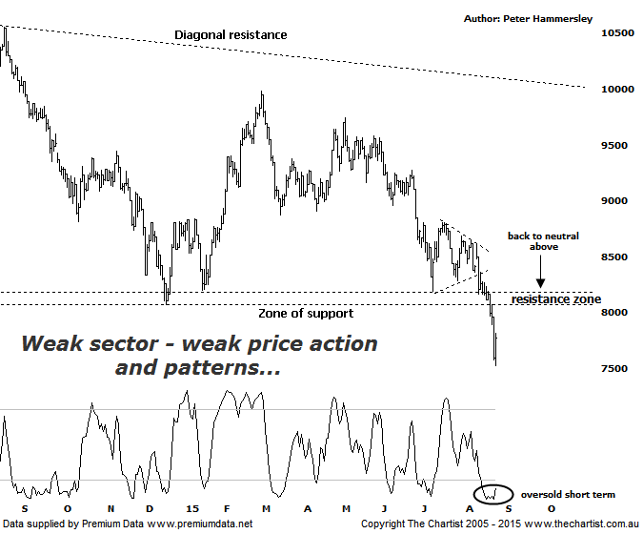

Bottom Line
25/8:
Daily Trend: Down
Weekly Trend: Down
Monthly Trend: Down
Support levels: 6423
Resistance levels: 9983 / 11244
Video Analysis
Watch Video Analysis Here
Technical Discussion
During our last review we were asking the question whether the Materials sector was trying to lock in a low. Short term weakness down to the zone of support was anticipated though ideally we wanted to see buyers return just above 8000 which clearly hasn’t been the case. Not only has weakness ensued but the zone of support has been penetrated with a serious degree of attitude which in itself is reason for concern. Many analysts continue to point the finger at China’s continued slowdown as the reason for the recent fall over the edge of a cliff for commodity prices though in reality that country’s slowdown is old news. That said iron ore, lead, nickel and copper etc. took a big hit last night which at the end of the day is all that matters. Yes, we can all speculate as to the reason for the massive underperformance of the XMJ but it doesn’t help one iota in trying to determine when a low is going to be locked in. With this in mind let’s take a look at the technicals.
Reasons to be cautious:
→ Investors continue to seek safety within companies offering sustainable dividends.
→ Struggling to make headway even though the US economy is growing, suggestive concerns remain in place with China.
→ Small resource stocks have come under pressure again having previously reversed from strong downtrends.
→ Technically the patterns are at a significant level both in terms of price and time.
I’m going to move back to the weekly chart this evening as there is little to be gained by concentrating too much on the recent surge in volatility and weakness. As mentioned above the key thing here is that the zone of support which was in position a couple of weeks ago has been smashed. However the small positive is that apart from yesterday, volume hasn’t increased which means at this stage there is no panic selling. In fact today saw a strong turnaround in the broader market which flowed through into the big miners like BHP and RIO. As always though, we can’t read too much into one day’s price action and much will depend on whether the buyer’s that stepped in today are going to be willing to chase price higher. Anything is possible during this period of volatility although a strong impulsive leg higher seems highly unlikely looking at the chart on both the daily and weekly time frames. The next zone of support sits around 6423 and although it’s not a prerequisite to hit those lower levels before a more substantial turnaround unfolds it’s more than feasible to get one final dip into that area. As it stands right here and now it would take a push above 10000 before thinking in terms of something more bullish unfolding longer term. The best thing we can do for now is watch from a distance as clarity on all time frames is lacking. Indeed, the patterns within the Banking sector are much clearer although I won’t go into detail as we also cover that sector this evening.
Trading Strategy
One thing’s for sure, we don’t advocate jumping on to any of the Miners at this stage despite today’s strong intraday turnaround. At the very least we’d need to see a minor higher swing low pattern or similar before getting involved from a trading point of view. In fact clear rejection from the minor line of resistance would be reason for aggressive traders looking for shorting opportunities to jump on with the expectation that the line of support is going to be the next port of call. For those looking for the longer term buying opportunity more patience is required.

