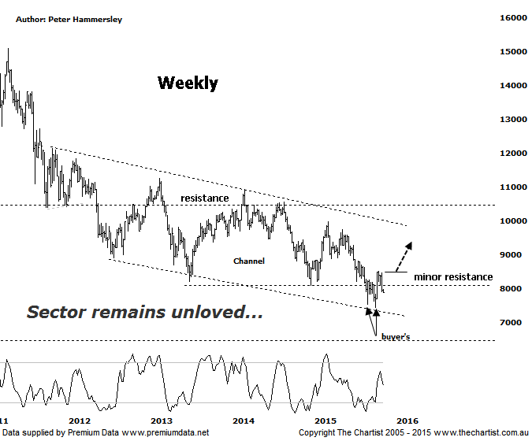
Bottom Line
2/10:
Daily Trend: Down
Weekly Trend: Down
Monthly Trend: Down
Support levels: 7844 / 7434 / 6423
Resistance levels: 8508 / 8807 / 9983
Video Analysis
Watch Video Analysis Here
Technical Discussion
Commodity prices in general remain subdued and whilst this remains the case the likes of BHP & RIO will find it difficult to gain any sort of traction. We also review BHP this evening and although a bullish reversal pattern appears to be setting up nicely it’s difficult to get bullish longer term both with the stock and the sector. As for the XMJ performance, all we can say is that it has been, and continues to be very disappointing. From the all-time highs in 2008 it's declined over 57%. Even from the 2011 highs the index has dropped over 50% which just reiterates the severity of the sell-off. One thing we have been mentioning quite often on these pages though is that when all and sundry are extremely bearish (extreme pessimism) it’s time to start looking for a buying opportunity. We’re still not convinced that we’ve reached those extremes quite yet and it could well be that one final washout is going to be required before getting interested in jumping into some of the Miners. Either way, we’ll need to see serious signs of accumulation before getting optimistic although at this stage nothing could be further from the truth.
Reasons to be cautious:
→ The continued slowdown in China continues to weigh on investors’ minds.
→ Investors continue to seek safety within companies offering sustainable dividends.
→ Struggling to make headway even though the US economy is growing.
→ Small resource stocks have come under pressure again having previously reversed from strong downtrends.
→ Technically the patterns are at a significant level both in terms of price and time.
We concentrated on the daily time frame during our last review and the formation of a descending triangle which was evolving just beneath a zone of resistance. It was important that the prior pivot low at 7523 wasn’t penetrated although this is exactly what transpired. At least a few buyers stepped up to the plate at those slightly lower levels which was a small positive although once again it’s evident that the rally failed to morph into something more bullish; this has been the trait for several years now with any rallies proving to be opportunities for holders to offload. Not a great trait to have although that is the reality. The make or break point over the short-term sits at 7844 which is the 61.8% retracement level of the recent bounce. If the sector it is to have any bullish aspirations then that aforementioned line in the sand most hold although it’s now within touching distance. On the weekly time frame shown here we can see that price has been declining within a falling channel since early 2012. On the positive side of things buyers did step up around the lower boundary a few weeks ago although it’s still a long haul even to get back up toward the upper boundary which essentially is the bullish longer term trigger. However, it’s difficult to envisage seeing a break higher out of the channel anytime soon. There’s no bullish reversal pattern here but there is an H&S in BHP which needs to be watched. One thing’s certain, if that stock is to reverse then a decent bounce in the Materials Sector is also going to have to occur.
Trading Strategy
Although we can’t totally discard the patterns on this particular chart they don’t give us a lot to work with – especially on the daily time frame. The point is, if you’re looking for an aggressive entry in some of the beaten down Miners you’ll have to concentrate on the patterns pertaining to the individual stocks themselves. At some point in time, whether it is in a week, month or even a year the Materials sector will bounce hard; we just need to be in a position to profit when that time arrives. As mentioned above, a bullish reversal pattern is present in BHP although it’s yet to trigger.

