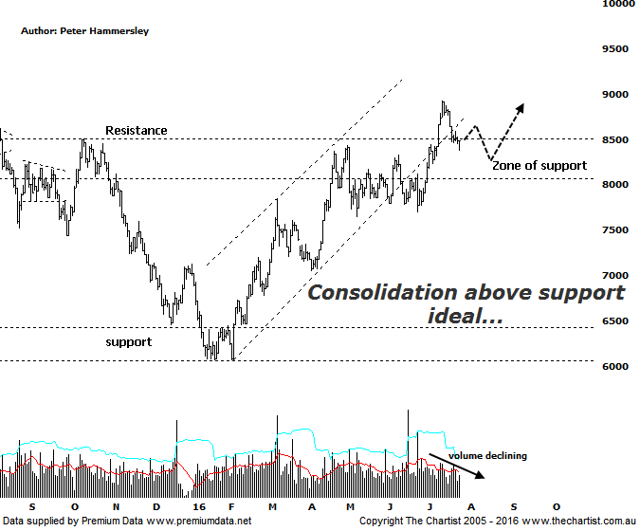
Bottom Line
26/7:
Daily Trend: Down
Weekly Trend: Up
Monthly Trend: Up
Support levels: 7699 - 7644 / 7048
Resistance levels: 8929 / 9983
Video Analysis
Watch Video Analysis Here
Technical Discussion
The Materials Sector has now rallied over 47% off the low made in February of this year which is an excellent effort to say the least. Of course, this follows a severe downtrend with an almost 60% decline taking place between April 2011 and the recent pivot low with the decline off all-time highs being even more severe. Still, trends have to reverse somewhere and in this instance the reversal higher commenced at a multi-year area of support going back to 2008. So does this mean we move to a bullish stance over the longer term? It’s a little too early to be popping the champagne bottles although price action this year has been much more impulsive in nature which is definitely a big step in the right direction. In fact, some exuberance has been witnessed recently with many of the smaller cap stocks within the sector moving higher in parabolic fashion. However, we have to remember that some of the beaten down miners have suffered declines of over 90% which means they are coming off severely oversold levels. Fundamentally it’s difficult to get too enthusiastic in regard to the likes of steel prices although these have been heading higher in China which has also had a positive effect on iron ore. The restructuring of the Chinese steel industry appears to behind firming prices although it’s difficult to find any evidence of this.

Reasons to remain cautious:
→ Data out of China remains mixed.
→ Investors continue to seek safety within companies offering sustainable dividends.
→ Struggling to make headway even though the US economy is growing.
→ Small resource stocks are looking a little overbought short-term.
→ Technically the patterns are at a significant level both in terms of price and time.

Following a consolidation phase between May and June of this year price has recently pushed higher which has actually resulted in a minor line of resistance being exceeded. This was noted during our last review and was a headwind that needed to be overcome before getting overly enthusiastic. As always, old resistance should become new support which is what’s keeping the door open for further strength, albeit a little further down the track. The potential headwind for the moment is Type-A bearish divergence on the weekly chart (not shown) which has already triggered. This is something that can never be ignored as it usually proves to be significant one way or the other. However, a sideways consolidation in this region over the coming weeks will be enough for our oscillator to unwind into the oversold position which would be a logical outcome when looking at this chart. One thing is for sure we wouldn’t want to see the new zone of support penetrated which means price will need to stay above the recent pivot low at 7644 in order for the immediate bullish case to stay intact. It’s also worth mentioning the volume which has been tapering off from the pivot low made on the 24th of June. This is exactly the opposite of what should be unfolding if a sustainable trend was in its early stages. Neither of those aforementioned two headwinds are major reason for concern but they should keep our feet firmly on the ground, especially over the coming weeks. It would take an immediate push up through the recent pivot high at 8929 to keep the current trend in motion which would also likely invalidate the bearish divergence meaning it’s a level to keep a close eye on should strength suddenly kick back into gear.
Trading Strategy
“…Although the sector is looking much brighter there is still no reason to be going out and buying the likes of BHP & RIO with our ears pinned back…” We continue to be sceptical in regard to the large miners with no indication at this juncture that they are going to surge higher in a strong impulsive movement. In fact, since our last review both BHP and Rio have done nothing but meander sideways and are sitting at almost exactly the same levels as those seen at the end of May. This of course is in stark contrast to many of the smaller cap stocks, which as mentioned above are looking a little overbought over the short-term. We certainly aren’t going to avoid the sector as it continues to show strength, but as always, we’ll only put forward recommendations if a low risk entry presents itself coupled with plenty of upside potential. We’ll just let the cream rise to the top and get involved with those companies sitting within strong uptrends or looking to reverse higher out of consolidation or basing patterns.

