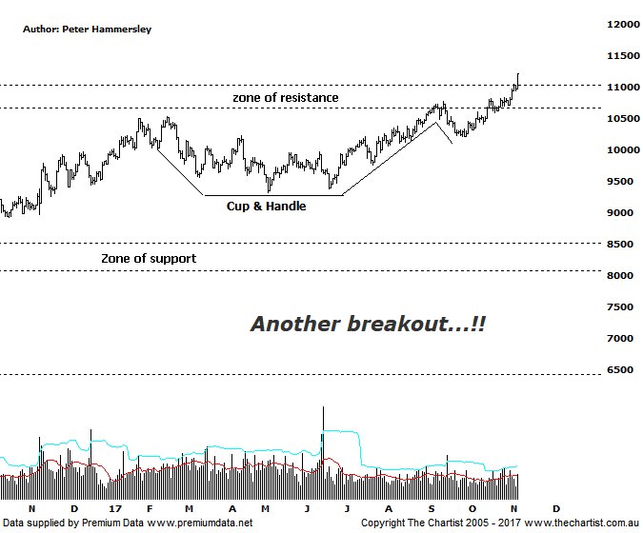

Bottom Line
7/11:
Daily Trend: Up
Weekly Trend: Up
Monthly Trend: Up
Support levels: 9322 / 8301 / 7774 / 6067
Resistance levels:10895 - 11244 / 11724 / 13059
Video Analysis
Watch Video Analysis Here
Technical Discussion
It’s been the turn of the big miners and therefore the Materials sector so far this year with the likes of Rio and BHP gaining some traction. In fact, this year-to-date the XMJ has gained 12% whilst the Banking sector has made no headway whatsoever, declining by just under 1%. We still believe this trait is going to continue for the rest of the year and likely well into next. As stated in last night’s review of ANZ, the problem for the banks (according to brokers) is going to be growth moving forward - or rather the lack of it. With global economies kicking back into gear, demand for commodities has been increasing and this is expected to continue over the short to medium term as a minimum. However, recent numbers show that steel demand in China has declined over the past month. Construction demand has also fallen sharply. However, a recent survey suggests that companies are going to replenish iron ore which is a positive. The fall in demand is not of concern to Macquarie, who state “…it’s a normal correction to the front loading of demand which occurs over the summer…”. Copper is also watched by many economists and analysts alike, as it’s viewed as an indicator of economic growth and health. Sentiment on copper still appears to be positive. Over the past month, fabricator and trade sales continued to increase due to broader growth in the major copper consuming sectors like construction, power and white goods. Fundamentally, there is plenty of good news around so let’s look at the technical picture.
Reasons to be more optimistic:
Economic growth is anticipated following Donald Trump’s victory which should be supportive of commodity prices.
Chinese consumption appears to be holding firm.
Investors’ appetite for risk has been increasing.
Small resource stocks have retraced following a reasonable leg higher.
Price has broken through major resistance.
A Cup & Handle has triggered.
We haven’t been running a wave count on this chart for some time now and although price action has been strong since our last review there is still no high probability count. As such, we’ll stick to more conventional pattern analysis. One pattern of interest last time was a Cup & Handle where it appeared that the handle had already been locked in. In other words, it was important that price headed higher pretty much immediately, and we haven’t been disappointed. Not only has strength been the way forward but price action has been strong and impulsive in nature over the past few weeks. The main pattern of interest last time was the solid zone of resistance which goes all the way back to February 2013. It was a similar situation for RIO (refer Thursday’s review) and BHP with both companies overcoming resistance over the past few days. The same has transpired here. Regarding the Cup and Handle on this chart, we can project the target by measuring the depth of the pattern and projecting it from the breakout which provides a target around 12200. This aligns nicely with the typical retracement zone of the whole leg down that commenced in May 2008. In fact, the 50% level sits at 11724 with the 61.8% level at 13060 which is where the next area of resistance sits. Get up through the 61.8% level and there is room for a multi-month trend to unfold with the next minor line of resistance sitting just above 15000. The index is looking overbought over the short-term and there’s even Type-B bearish divergence on the weekly chart (not shown) that needs watching. That said, price would have to reverse immediately for this to trigger although there’s no sign of it happening at this stage. The patterns look good, the trend is strong, so we simply go with it.
Trading Strategy
We continue to hold our long position in S32 from $3.10 with the trailing stop now amended to $2.99 which reduces a lot of the risk. If traction continues we’ll move the trailing stop to breakeven as soon as is practically possible. We’ve also recently initiated long positions in both RIO & ASL which appear to have plenty of upside potential. When patterns permit, we’ll put forward more setups within the position status page. If you want to follow some of the smaller companies, then check out the ASX Power Setups which has been offering plenty of opportunities recently.

